
INDUSTRY REPORT
Construction in the US
Mar 2026

About

IBISWorld
IBISWorld specializes in industry research with coverage on thousands of global industries. Our comprehensive data and in-depth analysis help businesses of all types gain quick and actionable insights on industries around the world. Busy professionals can spend less time researching and preparing for meetings, and more time focused on making strategic business decisions.

Table Of Contents | Standard

1. About 4
Codes 4
Definition 4
Related Terms 4
What's Included 4
Related Industries 4
Additional Resources 5
2. At a Glance 6
Key Takeaways 6
Products and Services 7
Major Players 8
Key External Drivers 9
Industry Structure 9
SWOT 10
Executive Summary 10
3. Performance 11
Highlights 11
Key Takeaways 11
Performance Snapshot 12
Outlook 20
Life Cycle 23
4. Products and Markets 24
Key Takeaways 24
Products and Services 24
Major Markets 28
International Trade 30
5. Geographic Breakdown 31
Key Takeaways 31
Business Locations 32
6. Competitive Forces 37
Key Takeaways 37
Concentration 37
Barriers to Entry 38
Substitutes 39
Buyer & Supplier Power 40
7. Companies 42
8. External Environment 43
Key Takeaways 43
External Drivers 43
Regulation & Policy 46
Assistance 47
9. Financial Benchmarks 48
Key Takeaways 48
Cost Structure 48
Key Ratios 50
10. Key Statistics 52
Industry Data 52

1. About
https://my.ibisworld.com/us/en/industry/23/about

Codes
NAICS 2017 - USA | 23
NAICS 2022 - USA | 23

Definition
The Construction sector comprises the construction of building or engineering projects, in addition to establishments engaged in the preparation of sites for new construction. Inputs for the construction process are purchased from both domestic and international suppliers. Key suppliers include other construction operators in this sector, manufacturers and wholesale trade operators. Markets for goods produced by this sector include residential, nonresidential and engineering avenues.

Related Terms

GENERAL CONTRACTOR (GC)
Also called a prime contractor. An individual or company that manages the construction of a structure for a property owner or developer. A GC may retain a labor force or use subcontractors.

DEVELOPER
An enterprise that prepares a real estate site for residential or commercial use. A developer raises capital, gains zoning approvals and hires contractors to design, construct and develop property.

COMPUTER-AIDED DESIGN (CAD)
The use of computer technology to aid the design and drafting of a part or product using software tools that can create 2D drawings or 3D models.

What's Included
- Construction of buildings
- Heavy and civil engineering
- Specialty trade contractors

Related Industries

Industries in the Same Sector
- Competitors:
  - No data available
- Complementors:
  - No data available

International Industries
- Commercial Building Construction in Canada
- Commercial Building Construction in the UK
- Building Construction in China
- Residential Building Construction in Mexico

Additional Resources
- National Association of Home Builders
- US Census Bureau
- US Department of Housing and Urban Development

2. At a Glance
https://my.ibisworld.com/us/en/industry/23/at-a-glance
Revenue  $3.5tr  ’21-’26 ↑ 2.3 %  ’26-’31 ↑ 2.0 % | Employees  11m  ’21-’26 ↑ 1.9 %  ’26-’31 ↑ 1.8 % | Businesses  4m  ’21-’26 ↑ 1.5 %  ’26-’31 ↑ 1.6 %
Profit  N/A | Profit Margin  N/A | Wages  $722.4bn  ’21-’26 ↑ 2.9 %  ’26-’31 ↑ 1.8 %

Key Takeaways

Performance
- As demand for construction services remained strong, contractors were able to pass along rising input costs. Nonresidential construction has been particularly important in recent years as high interest rates slowed residential construction activity.
- The second Trump administration's policies have and will impact the construction sector. Immigration policies and tariffs have increased labor and materials costs, respectively.

Products and Markets
- The 2021 Infrastructure Investment and Jobs Act supported the industry. Specifically, the bill benefited the heavy and civil engineering construction subsector.
- Making the industry more environmentally friendly is a source of innovation. Contractors who specialize in green construction can gain an edge.

Products and Services
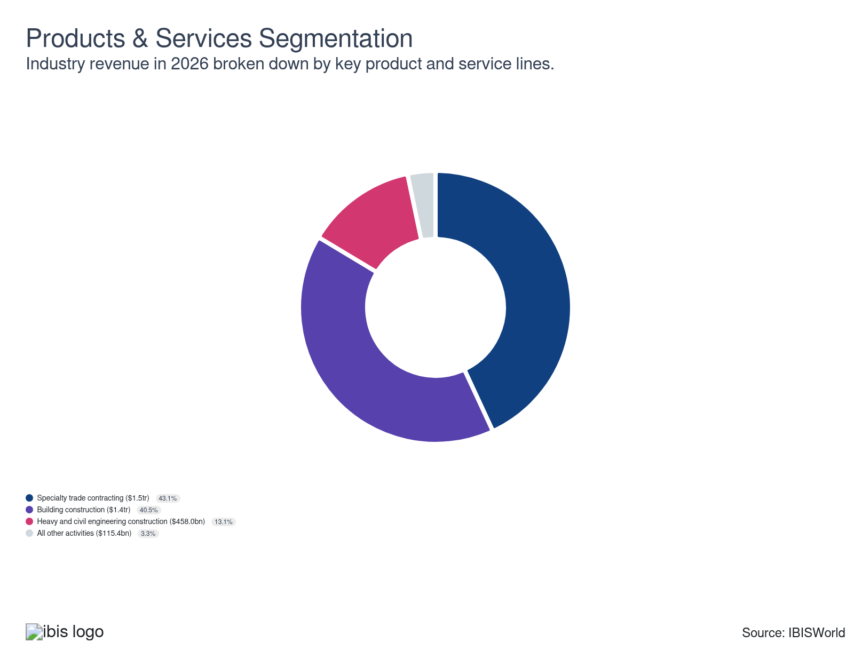

Major Players
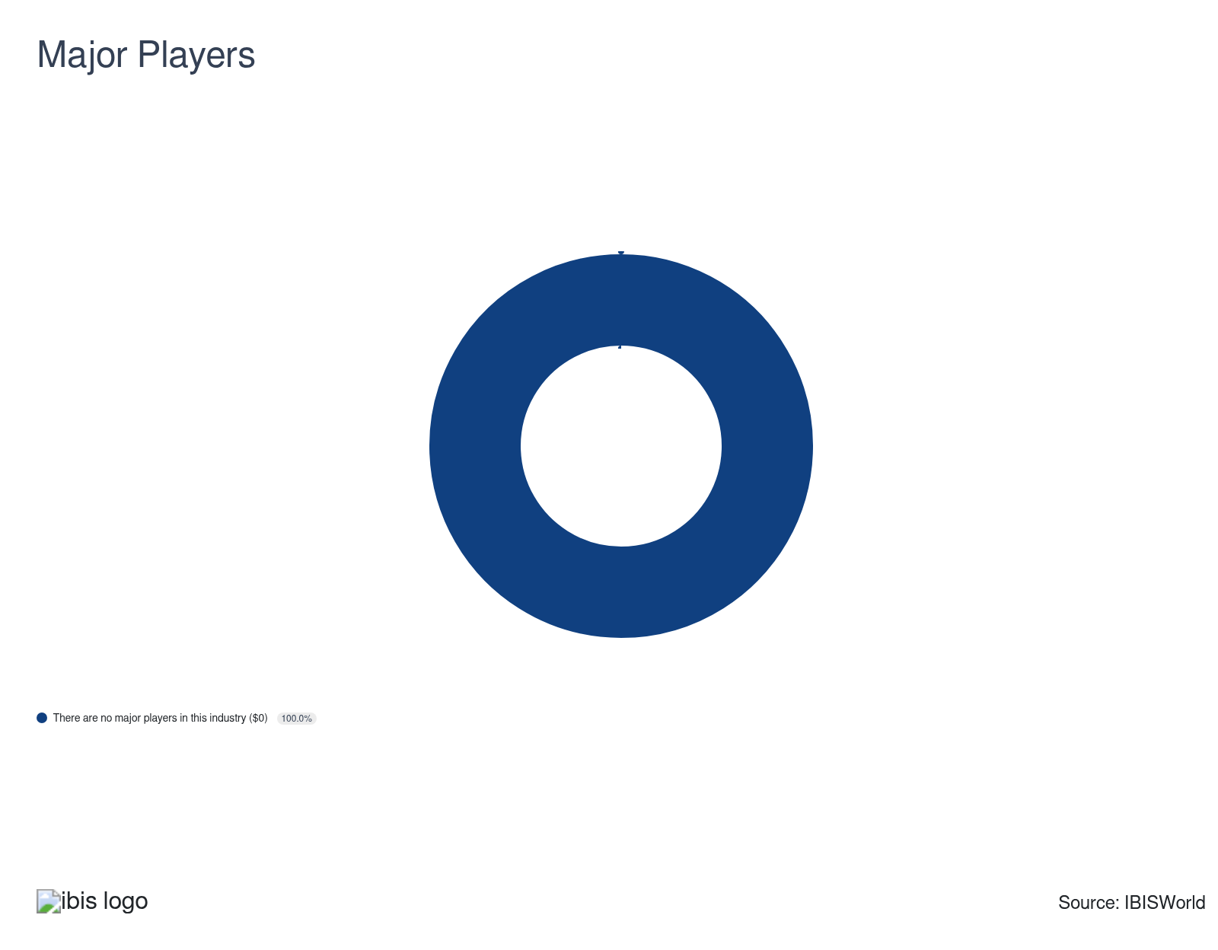

Key External Drivers
Key External Drivers | Impact
Value of private nonresidential construction | Positive
Value of residential construction | Positive
Corporate profit | Positive
Local and state government investment | Positive
Yield on 10-year Treasury note | Negative

Industry Structure
Characteristic | Level | Trend
Concentration | Low
Barriers To Entry | Moderate | Steady
Regulation and Policy | Moderate | Increasing
Life Cycle | Mature
Revenue Volatility | Moderate
Assistance | Low | Steady
Competition | High | Steady
Innovation | Moderate

SWOT
Strengths  High Profit vs. Sector Average  Low Customer Class Concentration  Low Product/Service Concentration  Low Capital Requirements | Weaknesses  Low Revenue per Employee | Opportunities  High Revenue Growth (2020-2025)  High Revenue Growth (2025-2030)  High Performance Drivers  Value of residential construction | Threats  Low Revenue Growth (2005-2025)  Low Outlier Growth  Local and state government investment

Executive Summary

Still building: While uncertainty surrounding tariffs poses a threat, recent interest rate cuts and strong underlying demand will keep the construction sector growing.
The Construction sector has expanded over the past five years; nonresidential construction activity has been particularly strong, and a surge in materials costs has driven up contractors' rates. Contractors in the sector construct buildings and engineer projects across a wide range of industries and applications, so construction sector revenue tends to correlate with broader macroeconomic conditions. Volatile interest rates, specifically, have impacted sector activity in recent years, with high rates having cooled residential construction activity since 2022; the stock of housing built amid post-pandemic low rates has discouraged new housing starts amid 2024 and 2025 rate cuts.
Sector revenue has risen at a CAGR of 2.3% to reach an expected $3.5 trillion in 2026, including an estimated decrease of -0.5% in 2026 alone amid an uncertain economic environment. Contractors have seen materials prices return to growth in 2025, growing an average of 2.9% year-over-year in 2025, following two years of declining prices, as the second Trump administration's policies have disrupted this previously stabilizing business environment. Ever-shifting tariff policies have made it harder to plan for the future and driven up the cost of materials, while immigration policies have threatened to further limit the sector's already shallow labor pool. This less predictable business environment has limited the average sector profit margin.
Moving forward, contractors are set to benefit from increasing commercial and infrastructure construction activity, aided by surging investment in AI infrastructure, including data centers and energy infrastructure. Basic macroeconomic drivers, including population growth (which is set to slow), will continue to expand the construction sector. Areas of the country with lower regulatory burdens, namely the Southeast, will continue to outpace the country as a whole in both construction activity and population growth. Overall, sector revenue is set to climb at a CAGR of 2.0% to reach $3.9 trillion in 2031.

3. Performance
https://my.ibisworld.com/us/en/industry/23/performance

Highlights
Revenue  $3.5tr  2021-26 CAGR ↑ 2.3 %  2026-31 CAGR ↑ 2.0 % | Employees  11m  2021-26 CAGR ↑ 1.9 %  2026-31 CAGR ↑ 1.8 % | Businesses  4m  2021-26 CAGR ↑ 1.5 %  2026-31 CAGR ↑ 1.6 %
Profit  N/A | Profit Margin  N/A

Key Takeaways
- As demand for construction services remained strong, contractors were able to pass along rising input costs. Nonresidential construction has been particularly important in recent years as high interest rates slowed residential construction activity.
- The second Trump administration's policies have and will impact the construction sector. Immigration policies and tariffs have increased labor and materials costs, respectively.

Performance Snapshot
Revenue: | ↑ 2021-26 Revenue CAGR +2.3%
Revenue  $3.5tr  ’21-’26 ↑ 2.3 %  ’26-’31 ↑ 2.0 % | 2026 Revenue Growth  ↓ 0.5 % | Revenue Volatility  Moderate
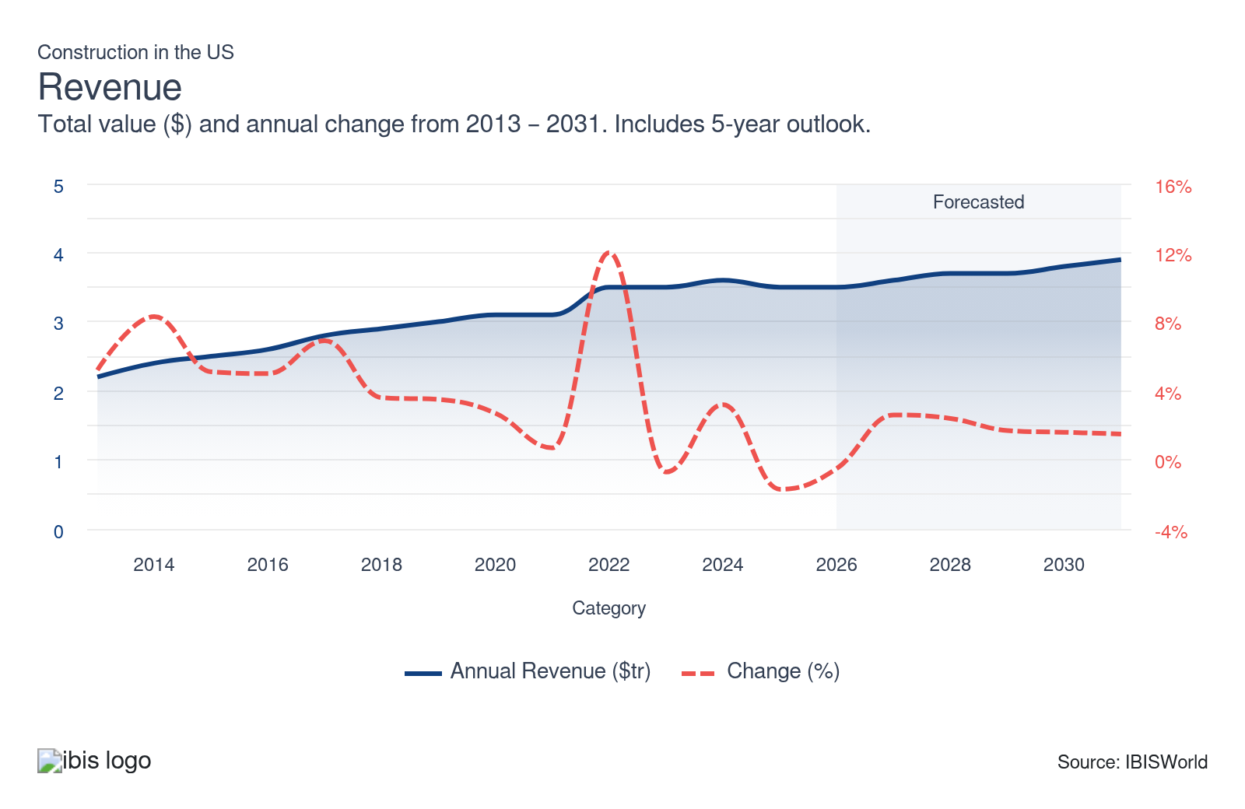
Employees: | ↑ 2021-26 Employees CAGR +1.9%
Employees  11m  ’21-’26 ↑ 1.9 %  ’26-’31 ↑ 1.8 % | Employees per Business  3  ’21-’26 ↑ 0.3 %  ’26-’31 ↑ 0.2 % | Revenue per Employee  $323k  ’21-’26 ↑ 0.5 %  ’26-’31 ↑ 0.2 %
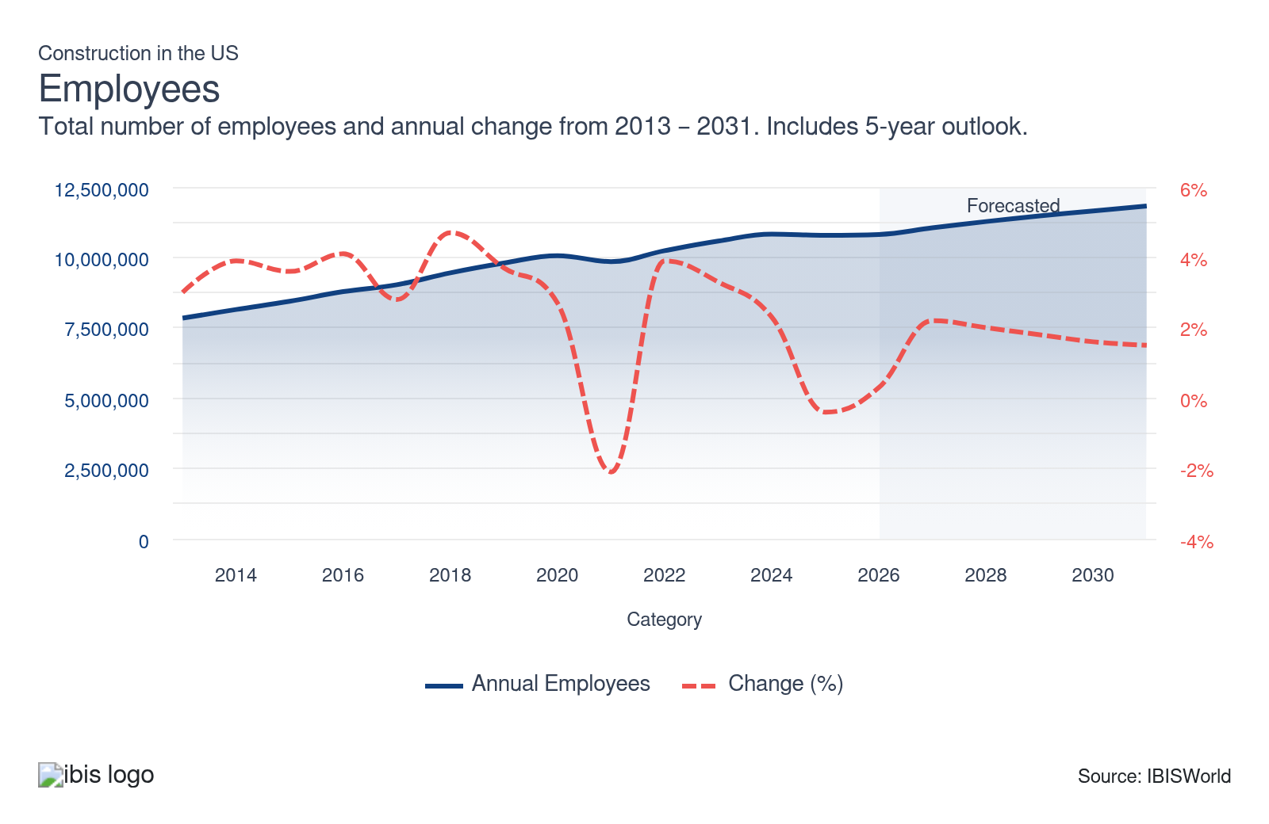
Businesses: | ↑ 2021-26 Business CAGR +1.5%
Businesses  4m  ’21-’26 ↑ 1.5 %  ’26-’31 ↑ 1.6 % | Employees per Business  3  ’21-’26 ↑ 0.3 %  ’26-’31 ↑ 0.2 % | Revenue per Business  $912.5k  ’21-’26 ↑ 0.8 %  ’26-’31 ↑ 0.4 %
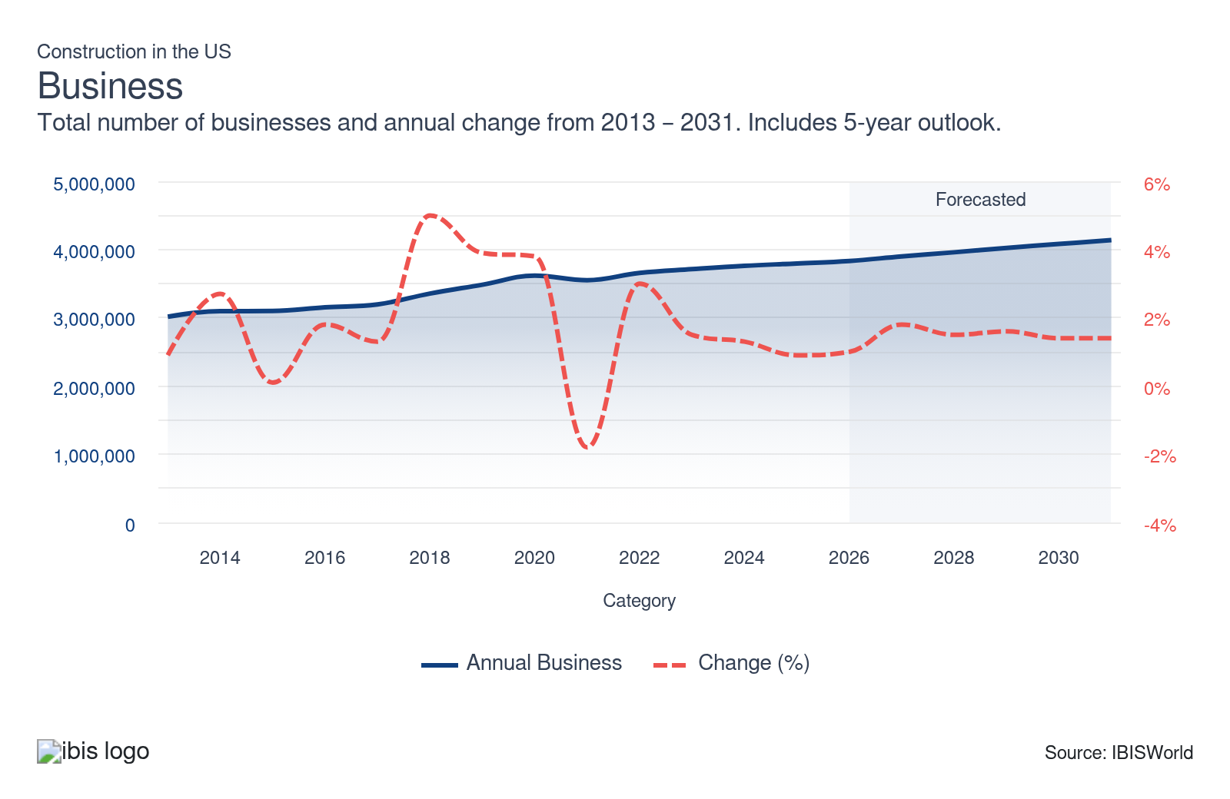
Profit: | N/A
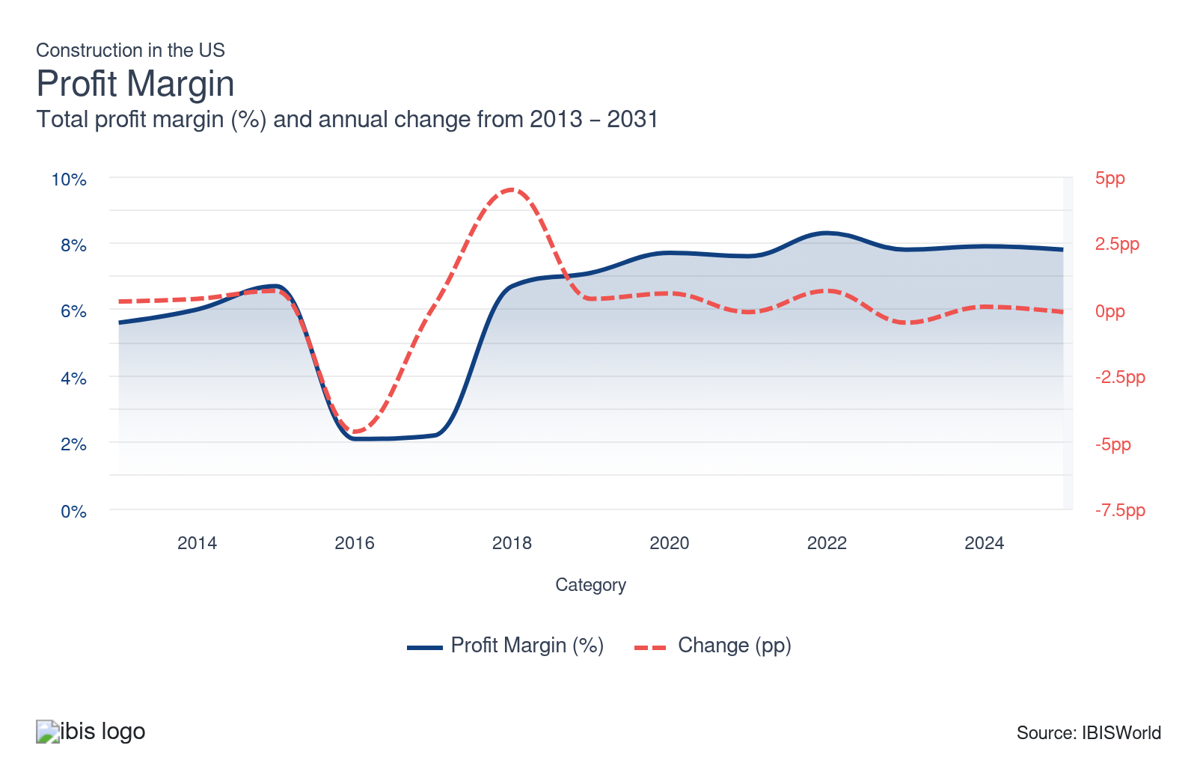
Current Performance
Current Performance

What's driving current industry performance?

High material costs have led to price-based gains
- The cost of various construction materials, including ready-mixed concrete, glass, structural steel, concrete panels and structural timber, has climbed over the past five years. Early in the current period, these costs surged because of supply shocks following the reopening of the economy and remained elevated because of supply bottlenecks and higher energy prices pushing up transportation costs. After two years of slight decline from this surge, materials prices returned to growth in 2025.
- According to the US Bureau of Labor Statistics, the price of construction materials increased by 51.3% from May 2020 to May 2022, then fell only 6.7% from May 2022 to May 2024. Contractors were able to navigate increasing material costs by passing costs onto customers, leading to price-based revenue gains. As prices stabilized, contractors had an easier time matching bid prices to the actual costs of projects.
- The price of construction materials rose an average of 2.9% year-over-year in 2025 as the second Trump administration's tariff policies disrupted supply chains and drove up input cost inflation. Construction costs are expected to continue rising in 2026 as long as current tariffs remain in place.

Interest rate flutuations have impacted construction spending
- From 2022 through mid-2024, high interest rates, meant to curb inflation, slowed investment in construction as an increased cost of capital has lowered demand for construction services. High interest rates have particularly negatively impacted residential construction, as the high cost of mortgage loans (which are indirectly influenced by the interest rate set by the Federal Reserve) has decreased spending on residential construction.
- With inflation showing signs of slowing, the Federal Reserve cut interest rates in 2024 and 2025, which stands to encourage rising construction spending across the sector. Still, these rate cuts have not necessarily caused a spike in residential construction activity, as new housing stocks remain elevated from the surge in activity caused by post-pandemic low rates.
- The interest rate set by the Federal Reserve does not have a one-to-one relationship with the 30-year fixed mortgage rate most homeowners in the US have. Still, the monthly average 30-year fixed mortgage rate in the US fell from 7.0% in January 2025 to 6.1% in January 2026.

Federal policies have benefitted nonresidential construction
- Infrastructure spending included in the 2021 Infrastructure and Jobs Act and the 2022 Inflation Reduction Act returned the value of utilities construction to growth in 2023.
- Along with provisions in the IRA, the 2022 CHIPS and Science Act has spurred growth in manufacturing construction spending as manufacturers of products like semiconductors, electric cars and batteries have been incentivized to establish domestic supply chains. This led to a 52.4% and 54.9% year-over-year increase in the annual value of manufacturing construction put in place in 2022 and 2023, respectively, according to the US Census Bureau. This growth slowed to 20.4% in 2024, for reasons including trouble securing skilled labor and a softer than expected market for electric vehicles.
- After surging following a boom in e-commerce during the COVID-19 pandemic, spending on warehouse construction has slowed. At the same time, data center construction has surged as AI has contributed to growing demand for computing power.
- In 2025, the Trump administration attempted to pause some funding included in the IRA and the IIJA, particularly that which targets the previous administration's climate goals. While this funding pause has faced legal challenges, it has been another source of uncertainty for the sector. As of December 2025, $294 billion in IIJA funds remained unallocated, leaving the disposition of those funds in question. Being able to navigate a shifting regulatory environment and provide guidance to clients is a potential opportunity for contractors.
- The Southeastern US poses slightly brighter prospects for the construction sector than the rest of the country. The region is experiencing population growth and industrial activity, which have been encouraged by federal support.

Labor is a key issue for contractors
- Construction, by its nature, is extremely labor dependent. When asked, contractors regularly cite a shortage of skilled laborers as a leading challenge to their businesses. Contractors need to pay high wages in order to attract and retain workers, limiting profit growth.
- There are some signs of a generational shift in attitudes toward the trades. Enrollment in vocation-focused community college programs increased 16.0% in 2024, and enrollment in construction trades specifically rose 23.0% from 2022 to 2023, according to the National Student Clearinghouse. ADP data shows that as of January 2024, 18.6% of workers aged 20 to 24 were employed in blue-collar jobs - 2.3 percentage points higher than in January 2019 and 2.5 points higher than workers aged 25 to 39, suggesting Gen Z is already gravitating toward blue-collar work at a faster rate than older cohorts.
- Traditionally union-heavy, the construction sector reached a record low in union membership in 2023. This is part of a long-term trend—the construction sector unionization rate has fallen from 39.5% in 1973 (when the US Bureau of Labor Statistics began keeping track) to 11.1% in 2025—and part of a recent acceleration; the rate of union membership was more stable in the 2010s, only falling by 0.5% from 13.1% in 2010 to 12.7% in 2020. This acceleration came in spite of the Biden administration's efforts to up unionization rates, including attaching wage and apprenticeship requirements to Inflation Reduction Act funded projects. The Trump administration has signaled support for reducing union-only project labor agreement (PLA) mandates on federal projects. On the whole, lower unionization rates represent a shift in bargaining power towards employers.

What influences industry volatility?

The industry follows broader business cycles
- Since downstream demand for construction services comes from every corner of the economy, construction sector revenue grows and contracts along with general macroeconomic business cycles.
- For the construction sector, these cycles are influenced by movements in long-term interest rates, general economic growth, business activity and demand for housing (which is impacted by population trends).

Recent years have been particularly volatile
- Though volatility has still been low due to the large and varied nature of the construction sector, the sector has still seen relatively higher volatility in recent years.
- Low interest rates early in the current period drove growth; more recent high rates slowed growth; cuts in 2024 and 2025 are again set to promote growth. High inflation also induced volatility in the construction sector.
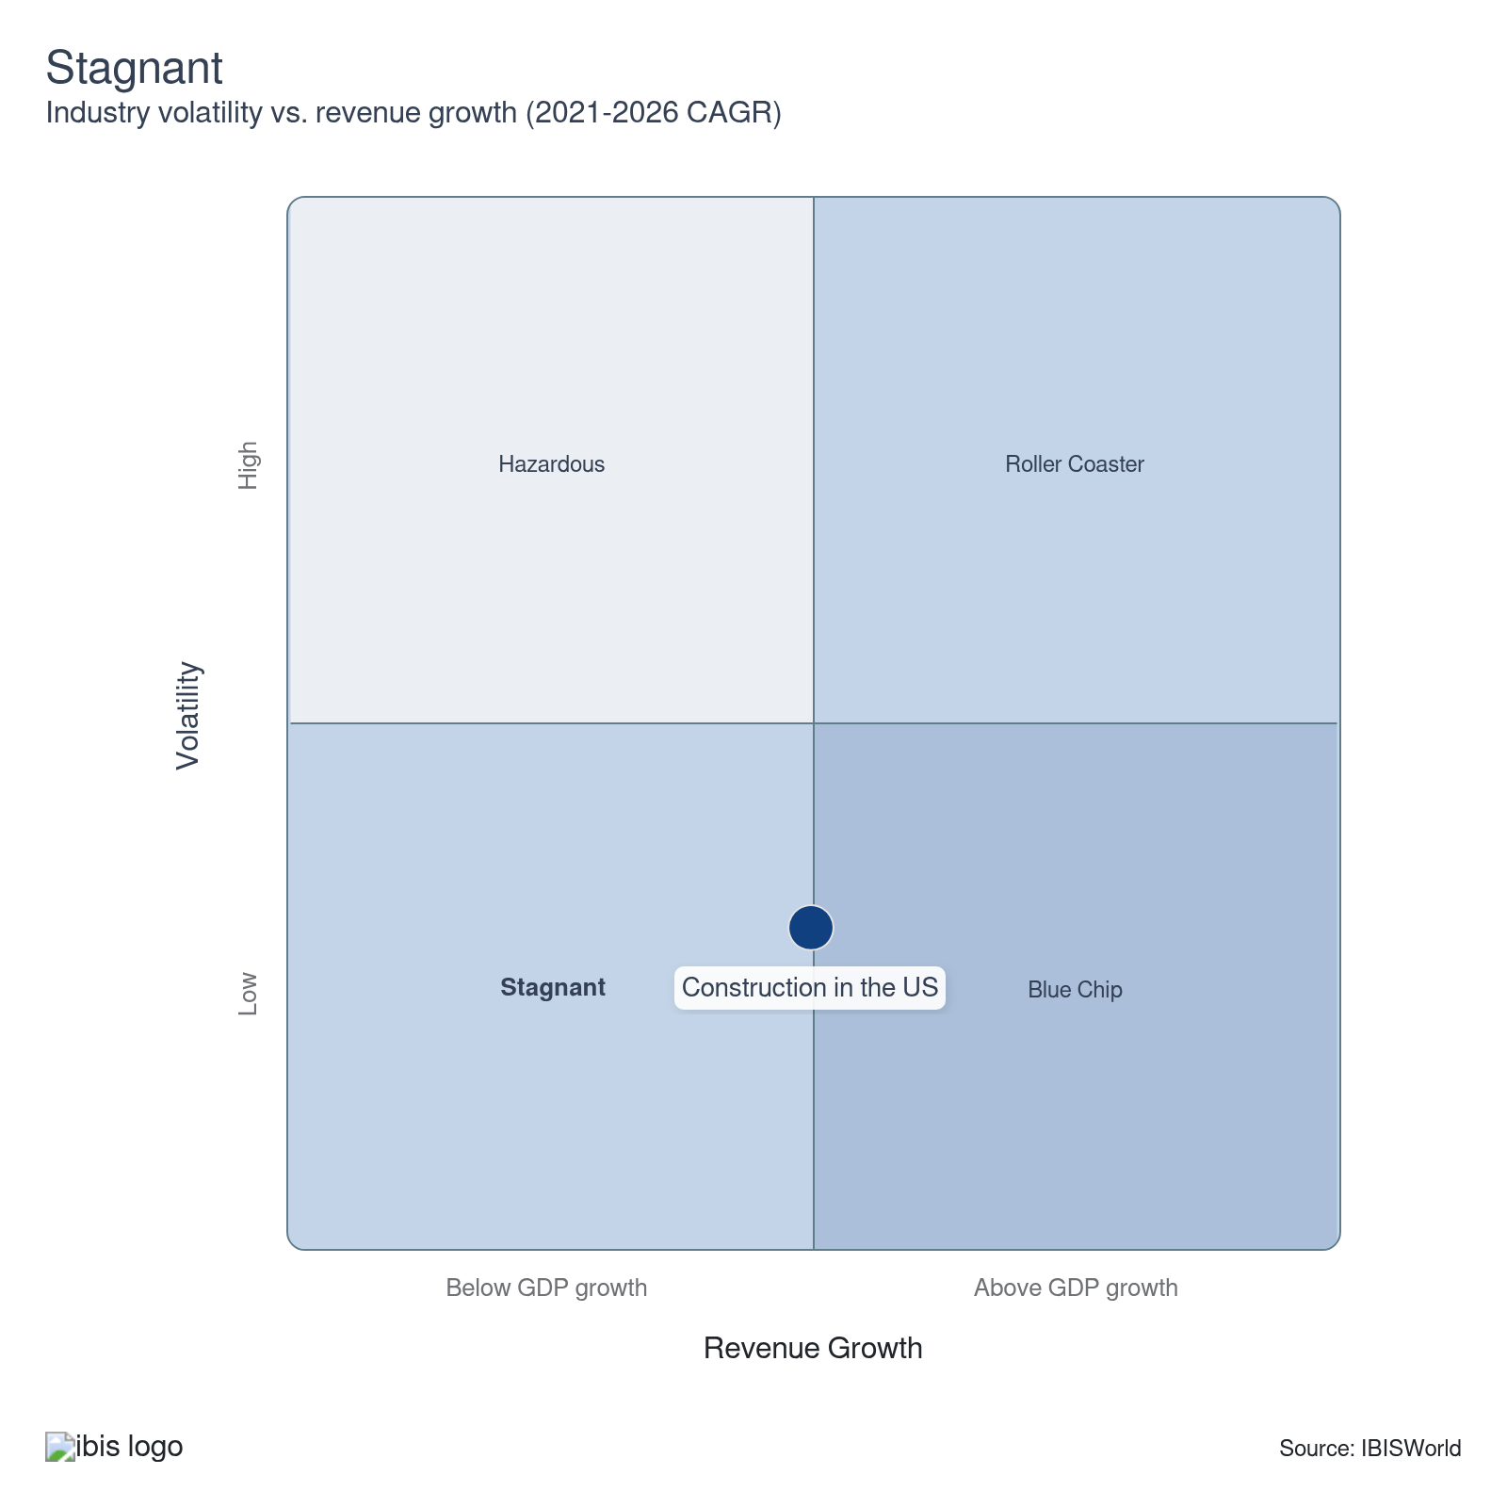

How do successful businesses overcome volatility?
Establish long-term working relationships with raw material suppliers
Building long-term ties with suppliers ensures stable material costs and reliable supply chains, reducing the risk of price fluctuations and shortages, which can hamper project timelines and budgets in volatile markets.
Develop strong project management skills
Effective project management helps construction contractors navigate unexpected changes and keep projects on track. It includes planning, coordinating resources, and adapting to on-site challenges, ensuring that projects are completed on time and within budget.
Secure a highly skilled workforce
A highly skilled workforce is important to this sector where considerable specialization is required, particularly in the specialty trade subsector.
Outlook | ↑ 2026-31 Revenue CAGR +2.0%

What's driving the industry outlook?

Falling interest rates benefit construction activity
- As the Federal Reserve began cutting interest rates in 2024 and continued to do so into 2025, the construction sector is set to benefit from a lower cost of capital in the near future. Still, interest rates will not reach the lows seen during the COVID-19 pandemic anytime soon.
- With many homeowners having secured loans at historically low interest rates in recent years, demand for residential construction has been lower as individuals have been reluctant to move and give up their low rates. If rates fall, this dynamic will improve.
- The Trump administration's tariff agenda has introduced meaningful uncertainty into the Federal Reserve's rate path. Broad-based tariffs have a demonstrated inflationary effect on goods prices, and rising inflation would likely delay or reverse further rate cuts, removing a key tailwind for the construction sector.
- The Trump administration has proposed using federal land for housing development. About 28.0% of the total land area in the US is federal land, though the vast majority of federal land is in the West. A significant increase in housing construction would certainly benefit the sector, but similar proposals have made in the past, including by the Biden administration, to limited effect.

Supply chain disruptions threaten contractors' average profit
- A broad escalation in global tariffs under the Trump administration has materially raised the cost of construction materials, which are sourced from global supply chains. A recent Supreme Court ruling has introduced uncertainty around the administration's tariff authority, but the administration has maintained it has alternative methods for imposing tariffs, and materials-specific tariffs on lumber, steel, aluminum and copper remain in place.
- Construction materials supply chains can adjust to tariffs to a certain extent; alternative materials and sources can be found for some materials, and domestic production of some materials will be able to increase as domestic production becomes relatively cheaper. Still, significant increases in domestic production beyond existing domestic industrial capacity (which varies among the many materials used by the sector) will take time and investment. Uncertainty around tariff policy, beyond the tariffs themselves, makes this less likely.
- Beyond tariffs, as extreme weather and environmental disasters, including wildfires, droughts and hurricanes become more common in coming years, global supply chains will face continued threats. Ongoing geopolitical conflicts, including the war in Ukraine, will also continue to threaten supply chains in the coming years.

Demographic trends will impact contractors
- Demographically, baby boomers made up the largest share of homeowners in 2025, retaking the spot from millennials, who had taken the spot in 2024, according to a report conducted by the National Association of Realtors.
- As millennials account for the largest generation in the United States and are increasingly making up most of the workforce (which supplements them with more income) their demand for housing will drive growth in residential construction in coming years.
- As baby boomers, the second-largest generation in the United States, continue to retire and either move away or into retirement homes, more residential housing will become available, which will spur residential investments, ultimately resulting in higher construction activity.
- Immigration enforcement actions by the Trump administration have already materially affected construction workforce availability, with high-profile ICE raids rippling across jobsites and causing undocumented workers to self-deport or simply not show up. According to an August 2025 survey by the Associated General Contractors of America, 92.0% of contractors reported difficulty filling open positions, 28.0% reported being directly or indirectly affected by immigration enforcement, and labor shortages were the leading cause of project delays.

Potential headwinds in office and warehouse construction
- Office rental vacancies are set to drop minimally. Considering how sharply they increased over the past five years, this is not a very promising outlook for contractors in such a critical market segment. Growing expenditures on office buildings for life sciences and research and development will continue to be a bright spot in this market.
- The conversion of some less-desirable offices to other uses could cause falling office rental vacancies, which would benefit the contractors who perform these conversions, but subtract from demand for more expensive new-build projects.
- Warehouse construction may continue to slow over the next five years. While e-commerce sales will continue to climb, increasing warehouse vacancy rates will likely discourage the same influx of new constriction contractors enjoyed over the past five years.
- Data center construction has not shown signs of slowing, however. The crypto-currency and AI industries have demanded growing computing power; if both of these industries grow over the coming years, data center construction activity will as well.

Red tape will continue to hold back construction activity
- Red tape and regulations will continue to be a limiting factor to expanding construction activity in the coming years. Worse in some areas of the US than others, things like environmental reviews drive up the costs and timelines of construction projects well beyond those seen in other countries. Indeed, UK consultancy firm Turner & Townsend found that six of the top ten most expensive places to build in the world were cities in the US (New York and San Francisco take the top two spots).
- California High Speed Rail, a rail project meant to link San Francisco and Los Angeles, has long been the poster child for this issue. Since the initial vote to begin the project was passed in 2008, the project has been pushed back by more than a decade and cost estimates have grown by the billions. A shorter section in the Central Valley of California running from Merced to Bakersfield is set to open between 2030 and 2033.
- The different levels of regulation across the country will mean that expanding construction activity will favor certain regions in the coming years. For instance, according to The Washington Post, the South received more than half of the clean energy investments stemming from the Inflation Reduction Act two years after its passing.
- The South has also seen the fastest population growth of any part of the country in recent years, while the country's most expensive housing markets have struggled to construct enough housing to meet demand. A relatively low regulatory burden (along with other factors, including population density) will continue to drive growing manufacturing and residential construction activity in the South in the coming years.
Life Cycle | Mature

Why is the industry mature?

Contribution to GDP
While the sector's IVA, which measures its contribution to the overall economy, has grown at a slower rate than US GDP, other measures indicate the sector is in the mature stage of its life cycle.

Market Saturation
Market saturation has remained steady, with more contractors located in large population centers. The broad range of activities included in the construction sector keeps market saturation consistent.

Innovation
The construction sector's activities have essentially remained the same for a long period of time, with more room for innovation downstream in the construction process.

Consolidation
The scale of this sector and its maturity virtually guarantee that consolidation activity is both occurring and is not fundamentally shifting the industry's structure.

Technology and Systems
While the construction sector, of course, uses technology to operate its services efficiently, change is slow and most systems are long-established.

4. Products and Markets
https://my.ibisworld.com/us/en/industry/23/products-and-markets
Largest Market  $1.5tr  Specialty trade contracting | Product Innovation  Moderate

Key Takeaways
- The 2021 Infrastructure Investment and Jobs Act supported the industry. Specifically, the bill benefited the heavy and civil engineering construction subsector.
- Making the industry more environmentally friendly is a source of innovation. Contractors who specialize in green construction can gain an edge.

Products and Services
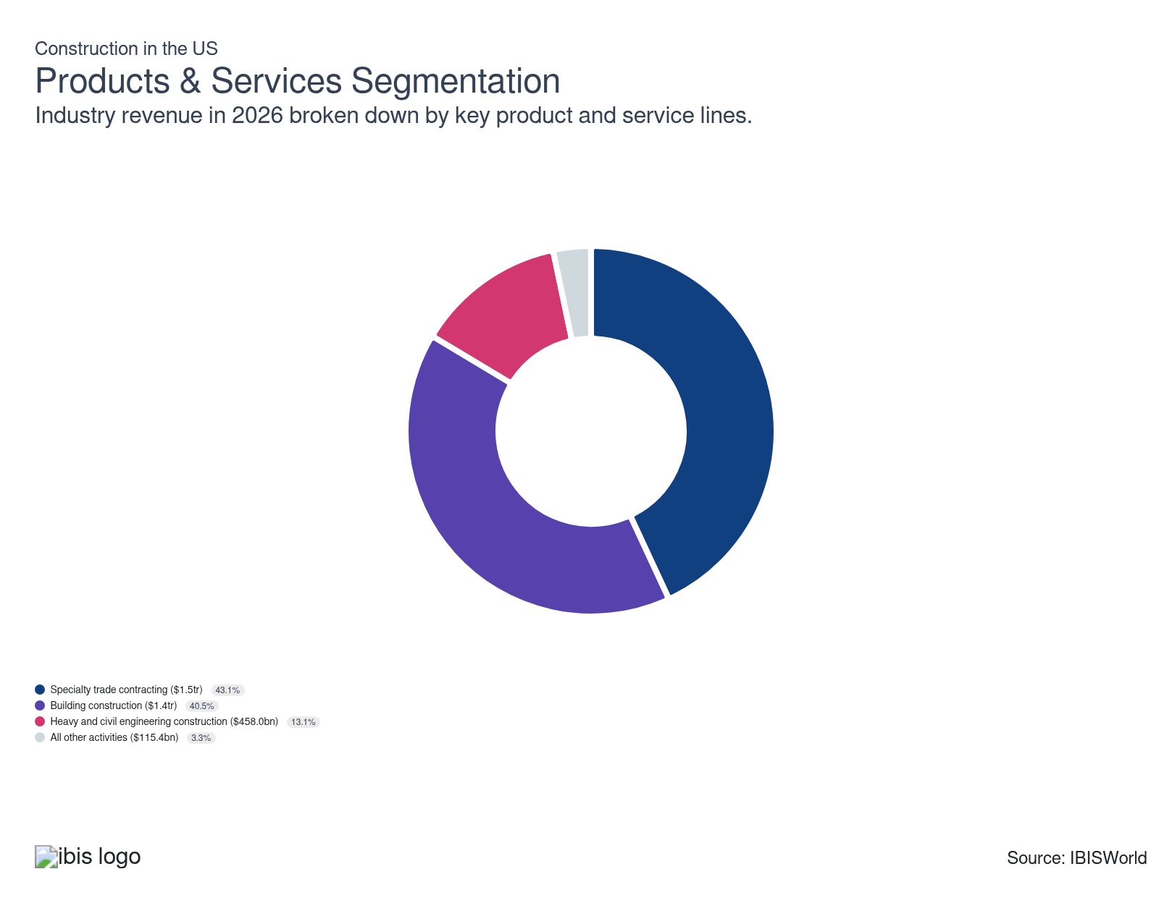

How are the industry’s products and services performing?

Building construction varies between residential and nonresidential construction
- This sector includes new work, additions, alterations, maintenance and repairs on all new and existing structures, as well as the on-site assembly of prefabricated buildings and the construction of temporary buildings.
- Over recent years, residential construction activity (including single-family homes and multifamily apartment complexes) has declined due to elevated interest rates, while nonresidential building construction (including warehouses, office towers, hospitals and data centers) activity has expanded with investments in AI.

Heavy and civil engineering construction has received federal funding
- This subsector includes businesses engaged in the construction of entire engineering projects, such as bridges, highways, tunnels, pipelines, sewer lines, utilities and dams.
- Additionally, this subsector includes specialty trade contractors whose primary activities are the production of specific components for such projects; the contractors that are included in this subsector generally perform activities that are specific to heavy and civil engineering construction that are not normally performed on buildings.
- This sector saw growth from funding from the 2021 Infrastructure Investment and Jobs Act which was passed following a dearth of federal infrastructure funding in prior years and was set to last through 2026, but has recently been disrupted by the Trump administration.

Specialty trade contracting and other products are varied
- This subsector comprises businesses engaged in performing specific activities, such as pouring concrete, structural steel erectors, site preparation, plumbing, painting and electrical work, involved in building construction but not responsible for the entire project.
- The varied nature of this subsector's services has led it to remain level as a share of overall sector revenue in recent years.

What are innovations in industry products and services?

Building techniques continue to evolve
- Most of the innovation in the construction sector takes place downstream in the construction process.
- Many current innovations involve making the construction process more environmentally friendly or otherwise efficient.
- Other innovations include 3D printing, the use of robotics and prefabrication. Contractors are beginning to make use of drones for inspections and site surveying.

Management makes use of technology
- There is some room for product innovation upstream in the construction process, which consists of subcontracting and project management.
- Technologies, including building information modeling, can facilitate project management. AI can streamline the preconstruction and project management processes, including using large language models to more efficiently complete requests for proposals and using image generators in the ideation and design process.

What products or services do successful businesses offer?
Invest in new technology to enhance operational efficiency and quality
Contractors who invest in new technologies like computer-automated design and building information modeling can operate more efficiently and gain a competitive edge. These management technologies streamline operations and improve project outcomes.
Allocate products and/or services to areas of greatest need
Contractors who offer their services in areas that are experiencing positive economic development will be able to secure more business.

Major Markets
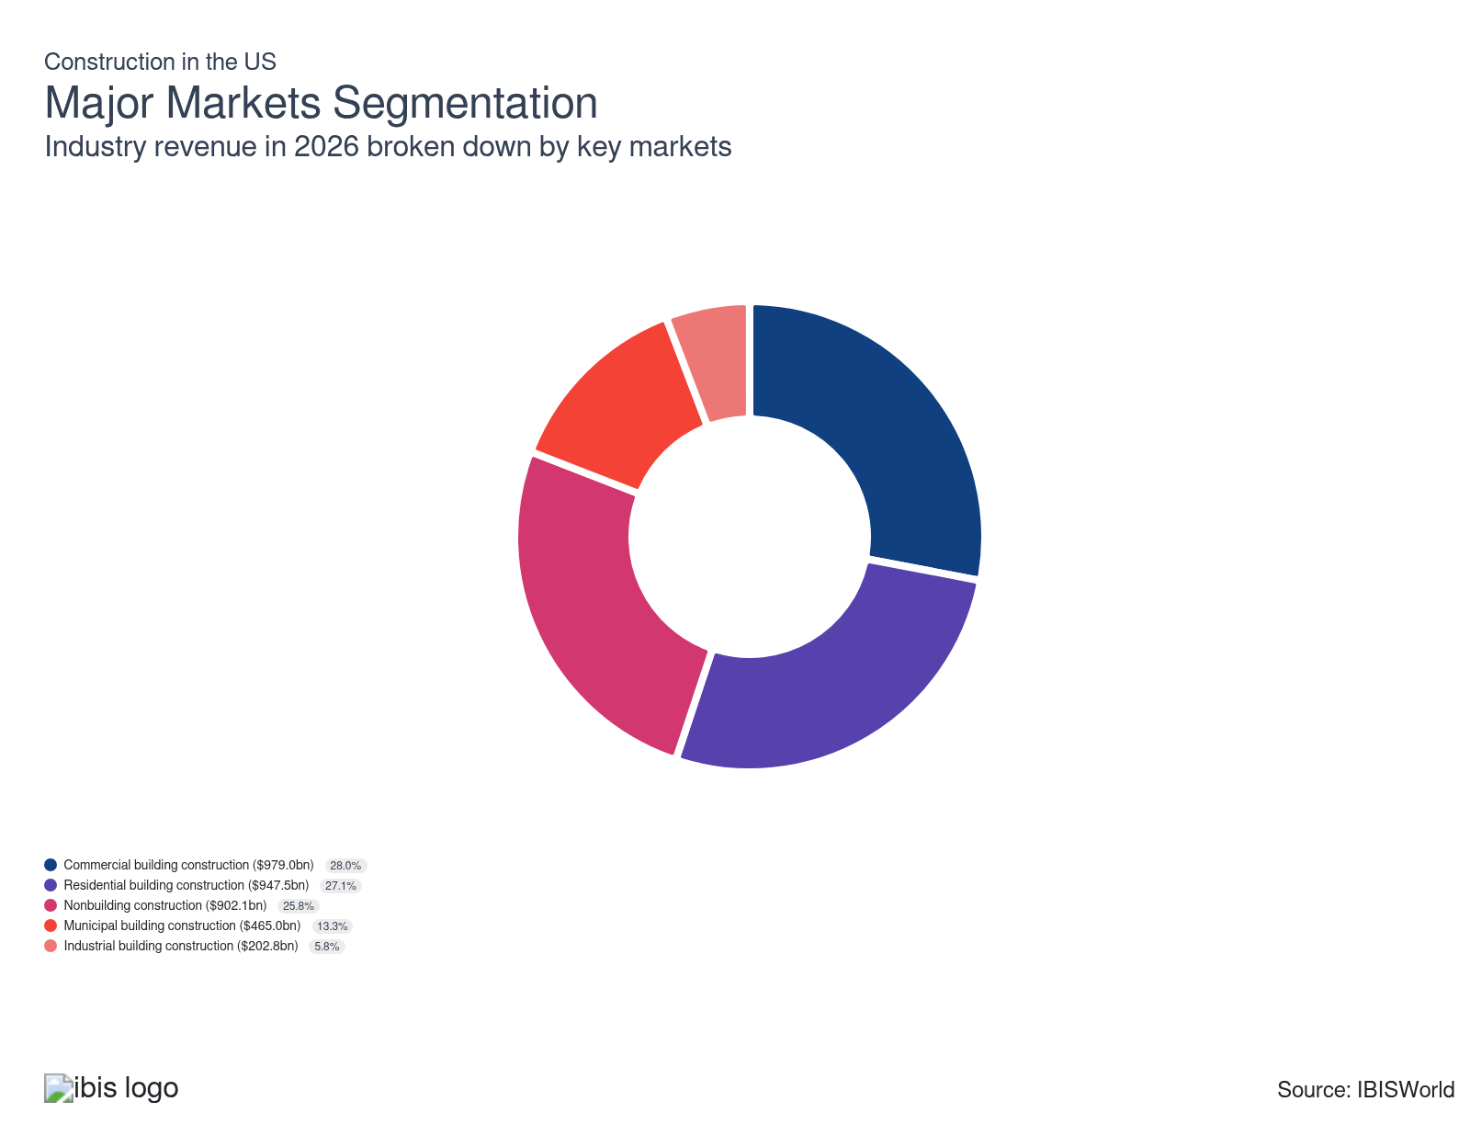

What’s influencing demand from the industry’s markets?

Residential building construction is impacted by mortgage rates
- This segment includes the construction, remodeling and renovation of single-family and multifamily residential structures, which may include single units, manufactured homes, townhouses, apartments and condominiums.
- Demand for residential building construction is influenced by current macroeconomic conditions, such as the level of unemployment, consumer sentiment, household income and mortgage interest rates, which collectively determine housing affordability and the availability of lendable mortgage funds.
- Current elevated interest rates have caused demand for this segment to decline after a brief rebound following the COVID-19 pandemic.

Industrial building construction has received federal support
- This segment includes the construction, renovation and repair of industrial buildings, excluding warehouses, in addition to the construction of structures whose production processes are similar to those of industrial buildings, such as incinerators, cement plants and other nonbuilding structures.
- Key downstream manufacturing markets, including domestic semiconductor, automobile and transportation manufacturers, experienced disrupted operations amid the COVID-19 pandemic. Still, many manufacturing industries built new facilities or retrofitted existing structures with advanced technologies in an effort to increase efficiency in producing and shipping their products in recent years.
- The Infrastructure Investment and Jobs Act, Inflation Reduction Act and CHIPS Act all include funding that supports this market segment.

Commercial building construction has been impacted by work from home
- This segment includes the construction, renovation and repair of commercial buildings and related structures, such as office, retail, hotel, agricultural and entertainment buildings.
- An increase in unemployment in 2020 alone as well as the longer lasting rise of working from home has drove down demand for this segment. As work from home has stuck around office vacancy rates have stayed high.

Municipal building construction has been mixed
- This segment includes the construction, renovation and repair of institutional buildings such as schools, hospitals, churches, civic centers and prisons.
- This subsector has experienced mixed as government stimulus programs wound down, leading to an increased reliance on private investment.

Nonbuilding construction has received federal support
- This segment includes the construction, renovation and repair of nonbuilding projects, such as highways, streets, bridges, tunnels, water lines, sewer lines, pipelines, power and communication transmission lines, dams, hydroelectric plants, subways and other mass transit projects and other nonbuilding structures.
- The Infrastructure Investment and Jobs Act of 2021 provided funding for this segment through 2026.

International Trade

Some industries don't directly import or export goods. See reports at the manufacturing level for international trade data on relevant products.

5. Geographic Breakdown
https://my.ibisworld.com/us/en/industry/23/geographic-breakdown

Key Takeaways
- Construction sector business locations are largely near population centers. Larger populations demand more construction services, and construction companies typically operate locally.
- The Southeast and the West are the two regions with the most construction businesses. This stems from the two regions being the nation’s most populous.

Business Locations
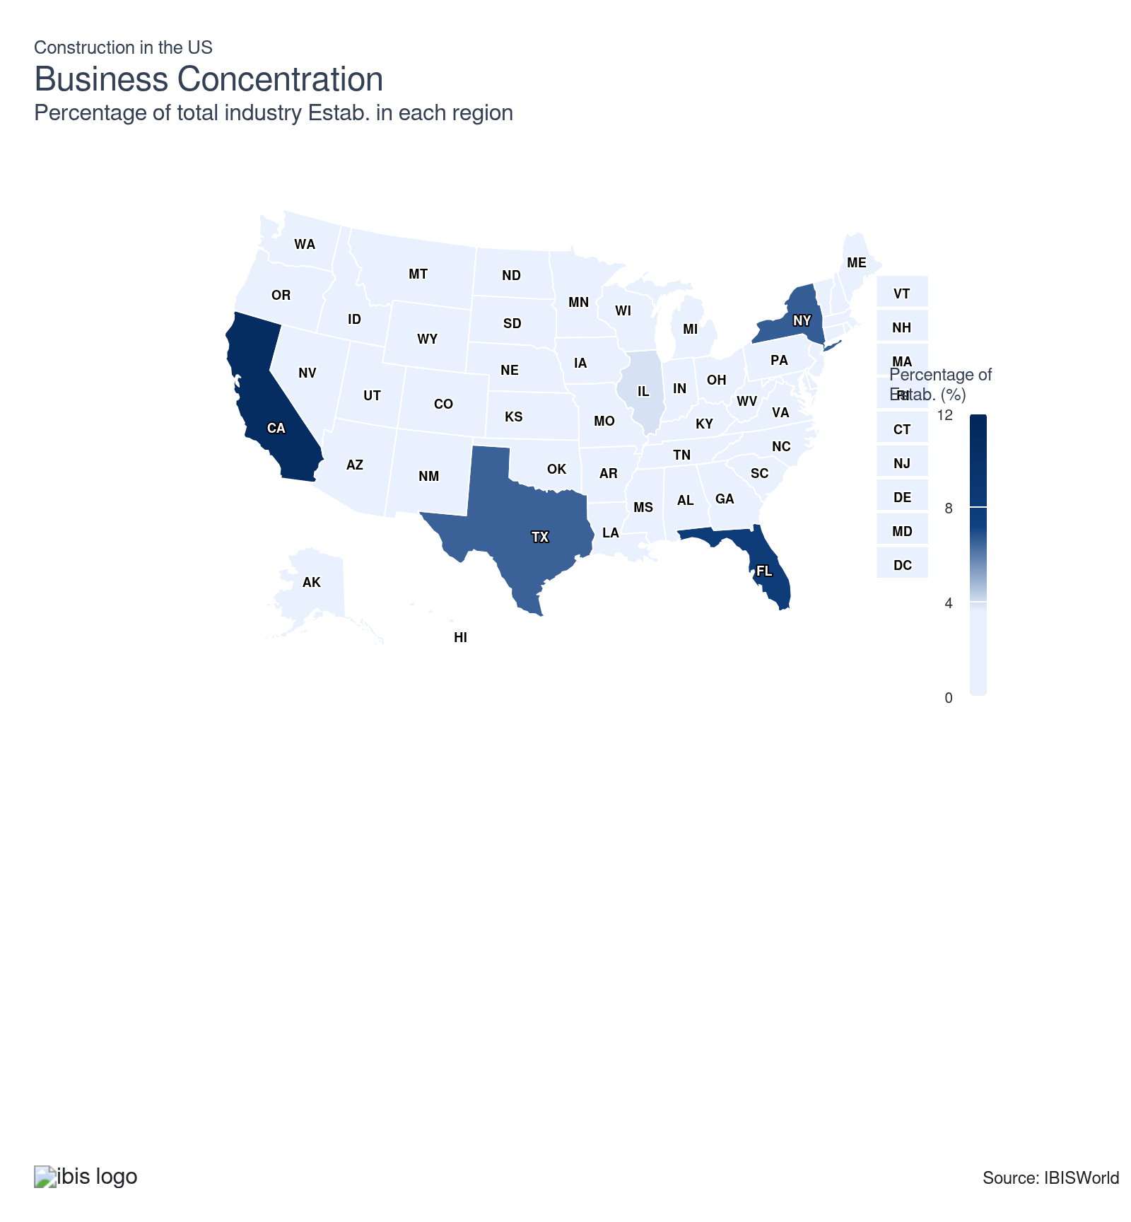
State | Estab.  Units | Estab.  % | Population  %
California | 80657 | 2.1 | 11.5
Florida | 60046 | 1.6 | 7.0
New York | 49602 | 1.3 | 5.8
Texas | 49326 | 1.3 | 9.4
Illinois | 29145 | 0.8 | 3.7
Pennsylvania | 27450 | 0.7 | 3.8
North Carolina | 25421 | 0.7 | 3.3
Washington | 25100 | 0.7 | 2.3
New Jersey | 21656 | 0.6 | 2.8
Georgia | 20096 | 0.5 | 3.3
Massachusetts | 20080 | 0.5 | 2.1
Ohio | 20299 | 0.5 | 3.5
Virginia | 20200 | 0.5 | 2.6
Colorado | 19672 | 0.5 | 1.8
Michigan | 19831 | 0.5 | 3.0
Minnesota | 16938 | 0.4 | 1.7
Maryland | 14251 | 0.4 | 1.8
Wisconsin | 14053 | 0.4 | 1.7
Arizona | 13487 | 0.4 | 2.2
Indiana | 13881 | 0.4 | 2.0
Missouri | 13640 | 0.4 | 1.8
Oregon | 13885 | 0.4 | 1.2
Utah | 11136 | 0.3 | 1.0
South Carolina | 10676 | 0.3 | 1.6
Tennessee | 10831 | 0.3 | 2.1
Iowa | 8712 | 0.2 | 0.9
Idaho | 8450 | 0.2 | 0.6
Louisiana | 8170 | 0.2 | 1.3
Oklahoma | 8379 | 0.2 | 1.2
Alabama | 7964 | 0.2 | 1.5
Connecticut | 7882 | 0.2 | 1.1
Kentucky | 7541 | 0.2 | 1.3
Kansas | 7089 | 0.2 | 0.9
Nebraska | 6531 | 0.2 | 0.6
Arkansas | 5675 | 0.1 | 0.9
Montana | 5909 | 0.2 | 0.3
Maine | 5293 | 0.1 | 0.4
Nevada | 5379 | 0.1 | 1.0
New Hampshire | 4455 | 0.1 | 0.4
New Mexico | 4389 | 0.1 | 0.6
Mississippi | 3879 | 0.1 | 0.9
South Dakota | 3436 | 0.1 | 0.3
Hawaii | 2892 | 0.1 | 0.4
North Dakota | 2881 | 0.1 | 0.2
Rhode Island | 3265 | 0.1 | 0.3
Vermont | 2642 | 0.1 | 0.2
West Virginia | 2996 | 0.1 | 0.5
Wyoming | 2774 | 0.1 | 0.2
Alaska | 2516 | 0.1 | 0.2
Delaware | 2387 | 0.1 | 0.3
District of Columbia | 496 | 0.0 | 0.2

Where are industry businesses located?

The Southeast holds the most industry establishments
- The size and variety of services provided by the construction sector means demand is spread fairly evenly across the population. The material nature of construction activity limits the geographic area in which any single contractor in the sector is able to effectively operate.
- As the most populous region, it follows that the Southeast has the most construction sector establishments.

The West follows Southeast in number of industry locations
- The West is the second-most populous region in the US and is home to the second-most construction sector business locations.
- Most construction contractors operate only on a regional basis, keeping concentration down and leading to a more even spread of businesses across the country, largely according to population patterns.

California holds largest share of industry locations
- California, the most populous US state, has the largest share of construction sector establishments.
- California alone has the fourth-largest economy in the world (compared to nations including the United States), providing plenty of demand for the sector. Beyond population alone, the state's large economy and physical size provide for robust construction activity.
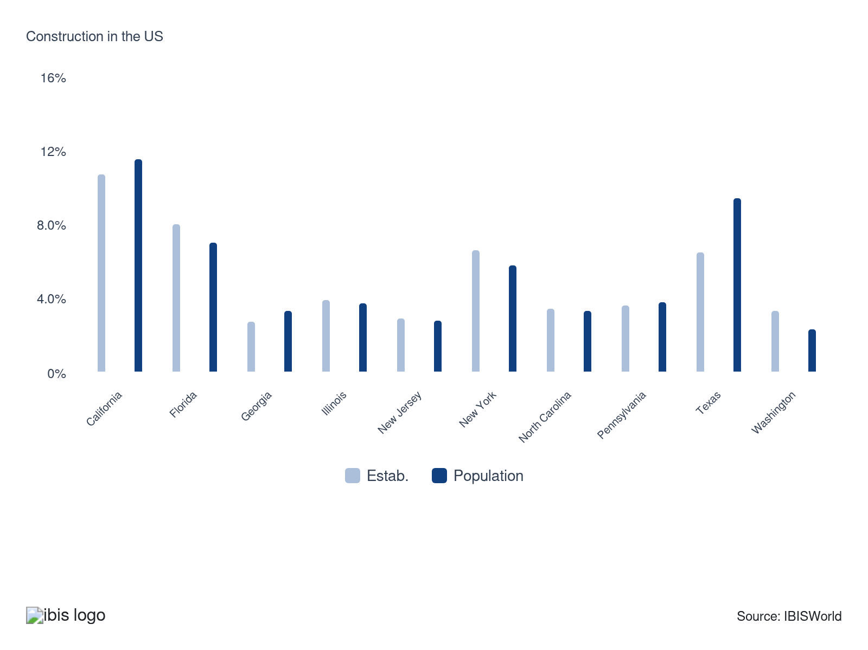

How do businesses use location to their advantage?
Ensure skilled labor is available
The construction sector faces a perennial labor shortage; operating in an area with a greater supply of skilled laborers benefits contractors.
Provide appropriate facilities
Contractors in the construction sector have various facilities needs. Operating in the proper location can increase operational efficiency for many contractors.

6. Competitive Forces
https://my.ibisworld.com/us/en/industry/23/competitive-forces

Key Takeaways
- Even the sector’s biggest fish are in a big pond. Since the sector is so large, the largest contractors claim small market shares.
- Most construction contractors operate regionally, diluting market share concentration nationally. When attempting to expand geographically, many contractors face logistic challenges.

Concentration
Low

What impacts the industry’s market share concentration?

The overall construction sector is very large
- The large size of the construction sector overall keeps any one company from gaining a large market share. It's exceedingly unlikely that any single company would gain a significant market share of the construction sector as a whole.
- The largest contractor in the industry accounts for less than 1.0% of overall construction revenue.

Construction contractors largely operate regionally
- Most construction contractors in the sector are smaller players that only operate in a confined region, diluting the overall national market. The material nature of construction work places physical limitations on the geographic reach of any one operator.
- A few of the largest contractors operate nationally or globally. Some US based contractors do business outside the country; some foreign-based contractors do business in the US.

How do successful businesses handle concentration?
Develop a strong reputation
Having a good reputation affects future workflow. Contractors seek to develop business relationships to improve future prospects, which helps them stay competitive in a crowded market.
Hire an experienced workforce
An experienced workforce is of importance to the construction sector. Considerable specialization is required, particularly in the specialty trade subsector.

Barriers to Entry
Moderate | Steady

What challenges do potential industry entrants face?

Legal
- Different states have different licensing requirements. Most states offer reciprocity for licensure, so long as the standards within each state are similar or at least as strict as those in the state where work is being performed.

Start-Up Costs
- Starting up in the construction sector requires relatively low amounts of capital, which is largely limited to purchasing transportation. Other initial purchases vary depending on what part of the construction sector a company wishes to enter.

Differentiation
- Established GCs in a given market pose barriers to success for new companies. Contracts are typically gained based on a contractor's record of accomplishments and on word-of-mouth recommendations, neither of which can be provided without previous work to refer to.

Labor Expenses
- GCs that want to retain a variety of specialized subcontractors to ensure quality standards or build an in-house construction team may experience difficulty attracting skilled tradespeople who generally prefer to work independently or for a larger, more respected operator.

How can potential entrants overcome barriers to entry?
Develop strong project management skills
Effective project management ensures that projects are completed on time, within budget, and to quality standards. This reliability builds client trust and can lead to more future contracts, easing entry barriers.
Develop strong working relationships with subcontracting building trade specialists
Partnering with reliable subcontractors ensures that projects run smoothly and on schedule, which enhances a contractor's reputation and project completion rate, making it easier to secure new contracts.

Substitutes
Moderate | Steady

What are substitutes for industry services?

In-house
- Businesses or consumers could opt to do sector-relevant work, like minor remodeling projects, themselves rather than hire contractors.
- Many large institutions have facilities management teams whose work may overlap some with the construction sector's.
- In most cases, in-house construction work reaches a certain threshold of scope before it is necessary to engage in services offered by the construction sector.

Government agencies
- Some government agencies may use their own employees to do construction, which would not be included in the scope of this report.
- A large amount of government construction work is contracted out to operators in this sector. Government contracts are often awarded according to stipulations regarding factors such as a company's ownership and worker profile or the relative price of a bid.

How do successful businesses compete with substitutes?
Secure a highly skilled workforce
Skilled workers ensure high-quality workmanship, attracting more clients and making substitutes less appealing. Quality labor directly influences project outcomes, enhancing credibility and client satisfaction.
Leverage the company's business expertise
Contractors in the construction sector with greater expertise in specialist areas will have greater success and will be able to charge higher premiums.

Buyer & Supplier Power
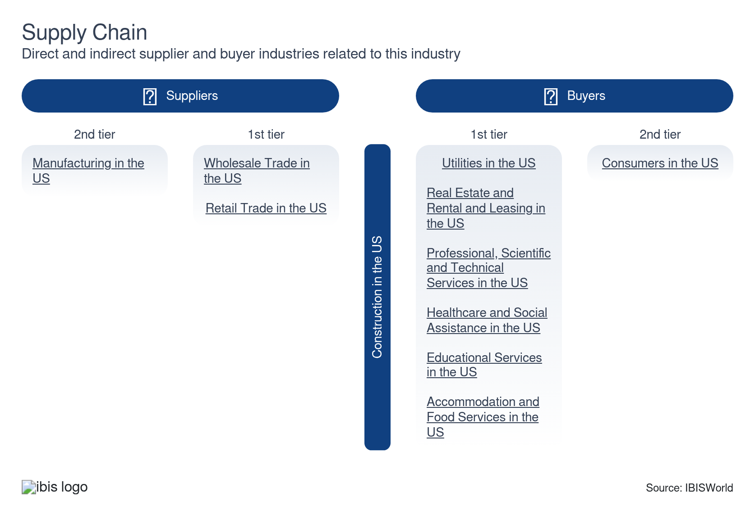

What power do buyers and suppliers have over the industry?

Buyers: A choice of contractors
Moderate | Steady
- Contractors' clients can often receive a range of submissions from different contractors, giving them choice. This drives contractors to compete on the basis of price when attempting to secure work.
- Customers proposing larger projects will have more power over price as contractors will be more willing to make marginal concessions in order to secure larger jobs.

Suppliers: A high information market
Moderate | Steady
- Prices—especially for more basic materials like steel, lumber or concrete—are set by the market and are well-known. This leaves any individual material supplier with limited price-setting power.
- Supply chain issues and inflation drove up costs within the past five years. In particular, fuel prices rose as a surge in demand following the COVID-19 pandemic met a limit in supply caused by the war in Ukraine. As materials became more difficult to obtain, suppliers gained power.

How do successful businesses manage buyer & supplier power?
Secure economies of scale
Operating at a larger scale can lower per-unit costs, giving contractors more leverage over buyers and suppliers. This can lead to better pricing and terms, enhancing competitive edge.
Develop strong working relationships with subcontracting building trade specialists
A large share of major construction projects are completed through the collective efforts of many subcontractors. Building solid relationships with reliable subcontractors ensures timely and quality work, which can mitigate supplier bargaining power.

7. Companies
https://my.ibisworld.com/us/en/industry/23/companies

No single company accounts for more than 5% of total industry market share.

8. External Environment
https://my.ibisworld.com/us/en/industry/23/external-environment

Key Takeaways
- The sector faces a thick net of regulations. They vary based on location and exist on different levels of government.
- The COVID-19 pandemic impacted volatility and sector assistance. Revenue volatility rose while PPP loans aided the industry.

External Drivers

What demographic and macroeconomic factors impact the industry?
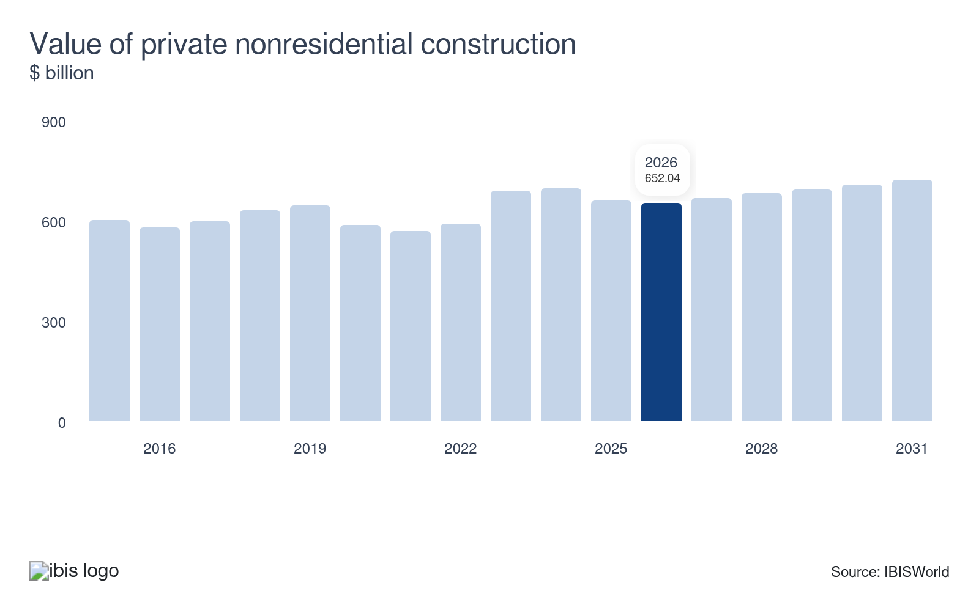
The value of private nonresidential construction includes new construction and renovations associated with all nonresidential buildings, such as commercial, industrial, educational and religious structures. The Construction sector derives most of its revenue from new construction, renovation and repairs on nonresidential buildings. As a result, construction contractors benefit from increased private nonresidential construction activity.
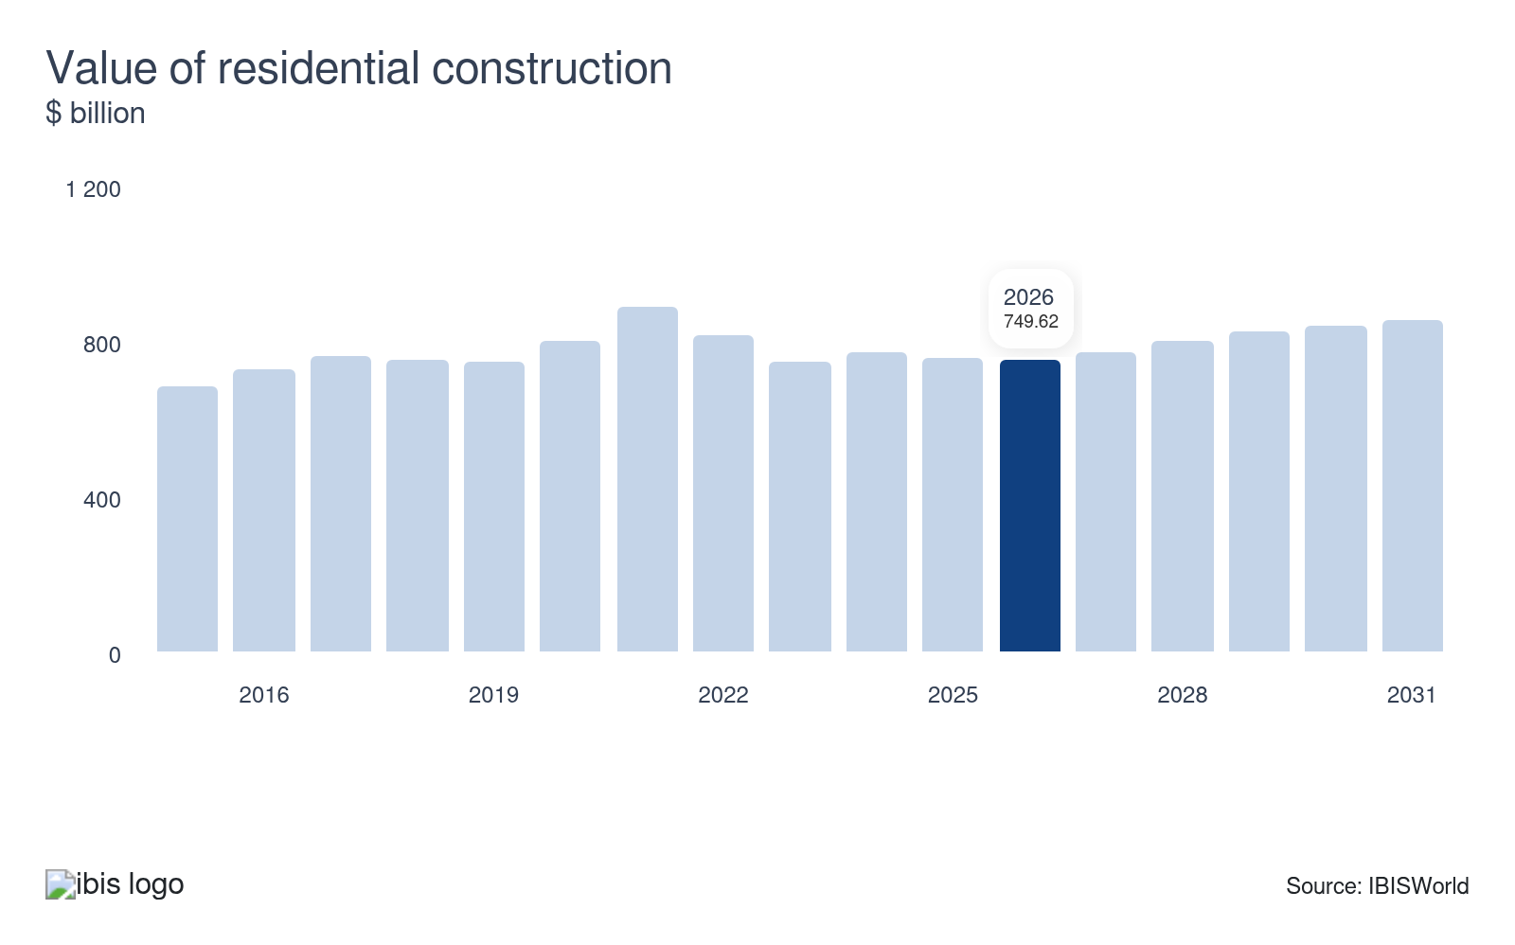
The value of residential construction includes new single-family and multifamily building projects. This segment also includes renovations to existing structures by homeowners, developers and landlords. The Construction sector benefits from increased investment in residential properties, as new homes require sector operators to complete construction while owners of existing structures contract sector operators for various renovations and upgrades. The rising value of residential construction represents a potential opportunity for the sector.
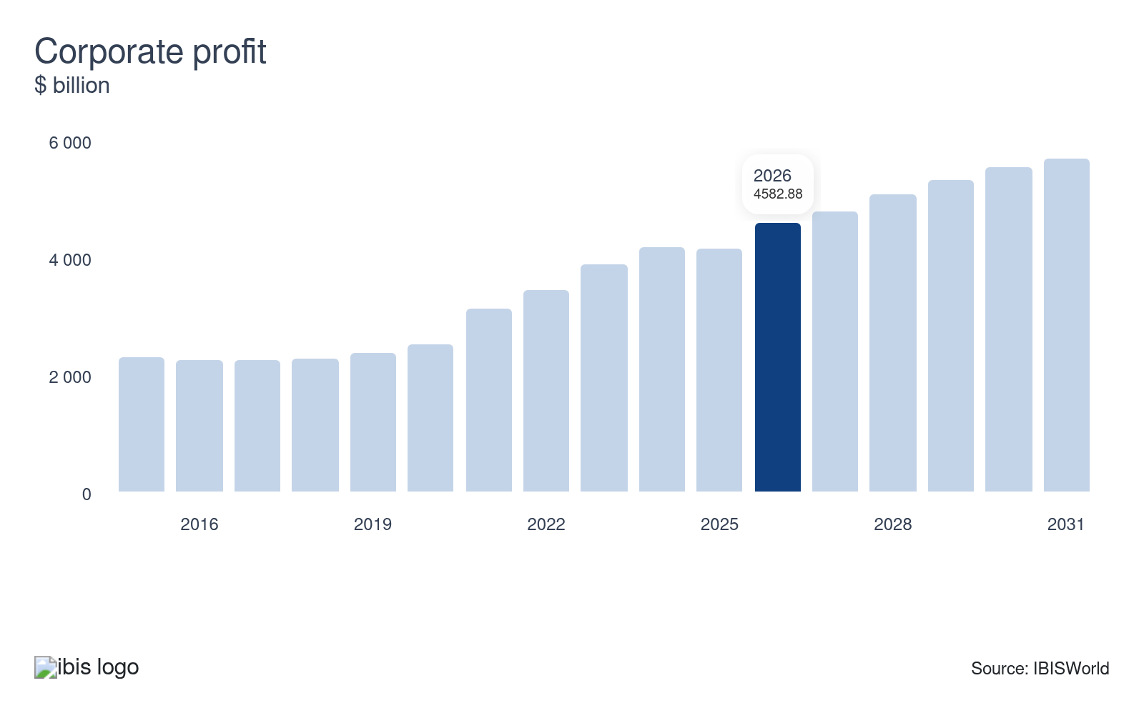
The Construction sector derives a substantial share of revenue from services provided to commercial businesses. Corporate profit influences a business's ability to expand operations; as corporate profit rises, companies become more able and willing to open new locations and hire more workers, driving demand for new commercial construction.
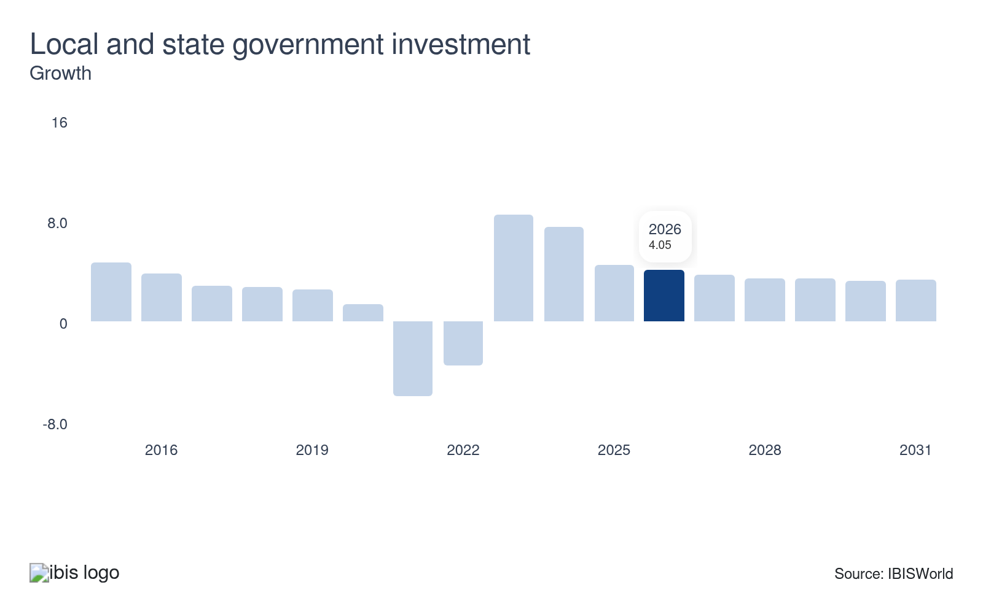
The Construction sector derives a substantial portion of revenue from services provided to the public sector. As local and state government investment increases, so does demand for construction services. Ongoing, and often noncyclical, investment in museums, courthouses, police stations and recreation facilities all drive demand. Declining local and state government investment poses a potential threat to the sector.
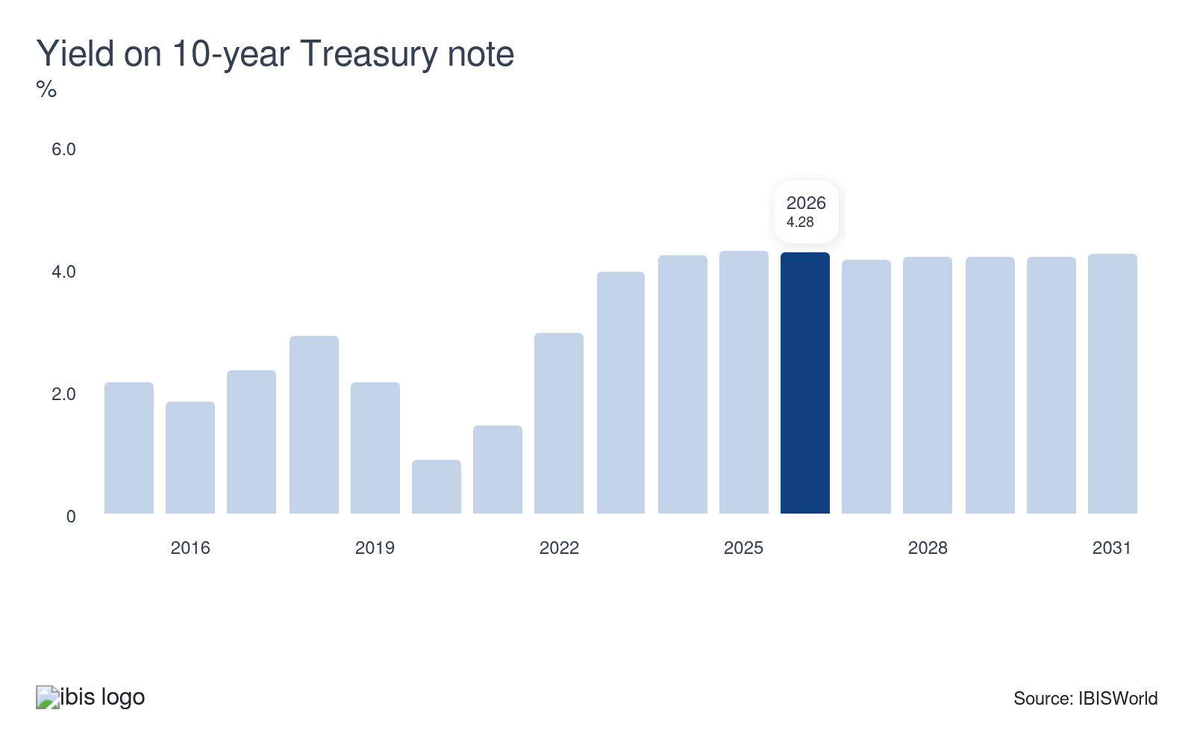
The yield on the 10-year Treasury note serves as a proxy for interest rates paid on loans. The need for new developments is largely dependent on the cost of financing; as the yield rises, so do the interest payments due on these loans, increasing the total cost of financing.

Regulation & Policy
Moderate | Increasing

What regulations impact the industry?

Health and safety regulations
Health and safety regulations require that workers wear protective clothing and helmets on-site and that safe conditions are provided for them, such as scaffolding, harnesses and ventilation. The Office of Safety and Health Administration (OSHA) enforces standards for construction industries. State and local building authorities assess and enforce this code.

Building and construction codes
Construction industries are subject to statutory regulations that cover building standards, pollution controls, competing land usage, disruption to existing businesses or residents and occupational health and safety issues. Compliance with regulations generally adds to the sector's underlying operating costs; in the long term, however, compliance may reduce an operator's exposure to litigation associated with faulty workmanship and workplace accidents, lowering insurance premiums.

Enviromental regulations
Operators in the construction sector are restricted by environmental regulations, including those set by the Environmental Protection Agency (EPA). EPA regulations aim to minimize environmental impact. They cover waste disposal, emissions and materials used. Construction companies must adhere to these rules to avoid legal issues and contribute to a healthier environment.

Zoning Laws
Zoning laws determine land use and building types allowed in specific areas. They help communities maintain order and ensure that development aligns with local plans. Construction projects must adhere to these laws to get the necessary permits.

Americans with Disabilities Act (ADA)
The ADA ensures accessibility in public buildings for individuals with disabilities. Construction companies need to design spaces that adhere to ADA standards, which include accessible routes, ramps, signage and restrooms. Compliance not only avoids legal penalties but also promotes inclusivity.

Labor Laws
Labor laws affect wages, working hours and conditions on construction sites. These include fair labor practices and equal employment opportunities. Following these laws helps ensure a fair and ethical working environment for all construction workers. Federal labor regulations are enforced by the Department of Labor.

Assistance
Low | Steady

What assistance is available to this industry?

Environmental regulations
The sector doesn't receive any assistance in the form of tariff protection due to the service-based nature of construction activity. However, certain industries within the sector benefit indirectly from the growing number of environmental regulations that govern water and waste infrastructure and treatment facilities, as well as from energy-efficiency standards. For example, drywall and insulation contractors (IBISWorld report 23831) have largely benefited from tax credits designed to increase energy efficiency.

Federal assistance
In recent years, the federal government has passed the Infrastructure Investment and Jobs Act, Inflation Reduction Act and CHIPS and Science Act, all of which include provisions that will stimulate the construction sector. The IIJA includes historic funding for infrastructure, the IRA includes significant support for the construction of green infrastructure and, along with the CHIPS Act, has driven a surge in manufacturing construction activity in recent years.

Industry associations
There are several industry associations and professional organizations that assist in advancing industry operators within individual construction industries. This includes the National Association of Home Builders (NAHB), which provides assistance across the spectrum of residential construction industries. Most industries that fall within the construction sector have at least one similar organization.

9. Financial Benchmarks
https://my.ibisworld.com/us/en/industry/23/financial-benchmarks
Profit Margin  N/A | Average Wage  $66,811  ↓ Lower than sector | Largest Cost

Key Takeaways
- The cost of construction materials has risen due to supply chain issues. As the industry operating environment has become more uncertain, the average profit margin has been challenged.
- Most of the sector’s costs are the cost of subcontractors. Many projects are done by general contractors who divide parts of a project among subcontractors.

Cost Structure
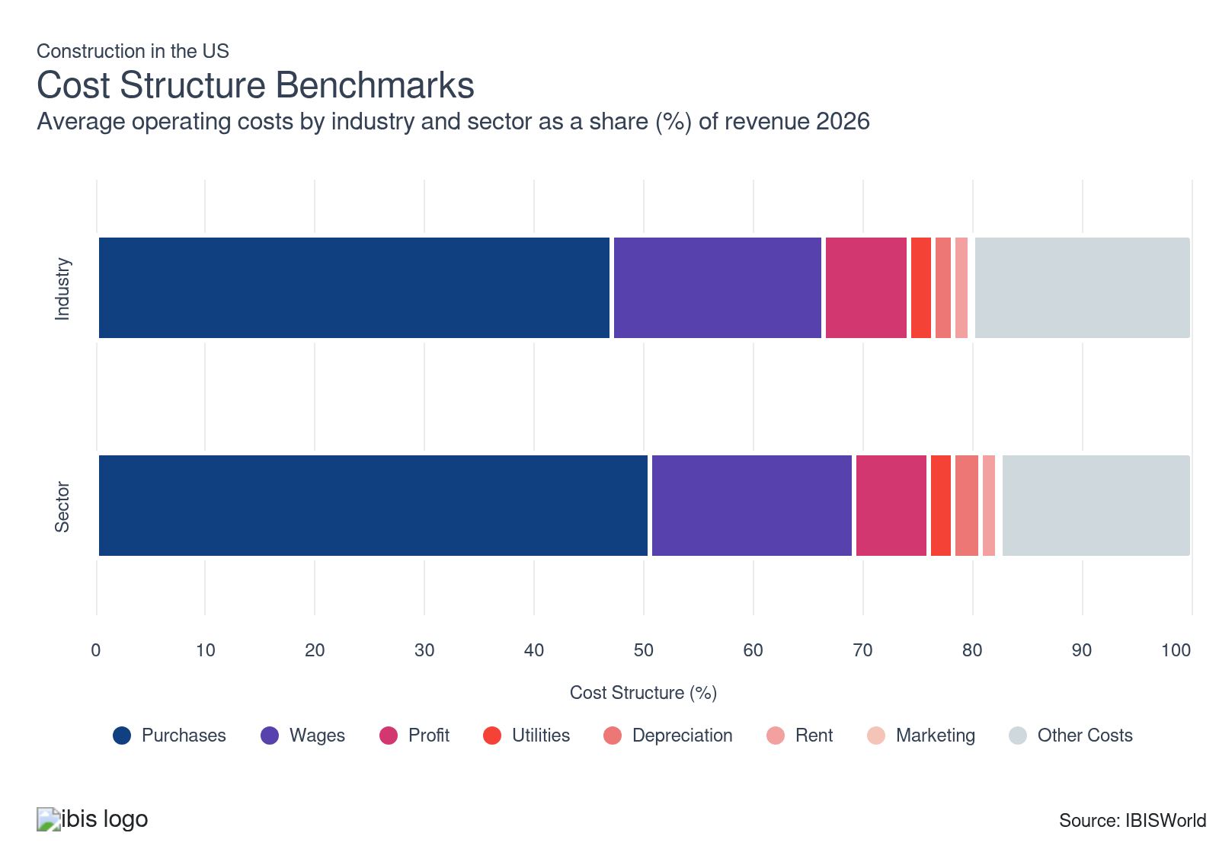
Chart displays current year only in the PDF version of this report. You can view and download chart for all other years associated with this industry on my.ibisworld.com.

What trends impact industry costs?

Profit has grown as costs have cooled
- The average industry profit margin has rose over the last five years as supply chain issues, which drove up the cost of materials, have largely abated.
- Moving forward, profit will be threatened by increasing tariffs' potential to disrupt supply chains. Contractors are also expected to continue to grapple with labor shortages.

Purchase costs have come back to earth
- Purchase costs are the largest cost segment facing construction, with the bulk of purchase costs coming from subcontractors. Most large construction projects are completed through the work of a number of subcontractors.
- The high upstream cost of materials also elevates purchase costs. Supply chain issues that came in the wake of the pandemic drove up purchase costs in the past, while supply chain issues from increasing tariffs threaten to drive up purchase costs in the future.

Other costs are significant
- Computer-aided design software has been increasingly purchased by general contractors, in addition to other modeling software that enables companies to better forecast and plan for a project's costs.
- Larger contractors typically provide surety bonds as an additional level of security for the completion of a project as promised.

Workers are the backbone of construction
- Wages are the third-largest expense for contractors since it is a labor-intensive sector. Wages have lagged revenue growth slightly, causing wages to fall as a share of revenue.
- Contractors hire third-party subcontractors to reduce wage costs. Subcontractors are paid on a per-project basis and are ineligible for the same benefits that full-time employees receive.

Reliance on reputation push down marketing costs
- While contractors must maintain a certain degree of outreach to potential customers via promotional materials, companies ultimately benefit the most from establishing strong reputations for high-quality work and timely completion of projects.
- Marketing costs are low and steady for the construction sector. Contractors may expend more capital on marketing when they begin operating to gain a foothold in local markets. Still, they primarily rely on establishing reputations and gaining word-of-mouth referrals in local markets.

Contractors enjoy low utilities costs
- Utility costs for contractors include electric, water, gas and waste disposal. These costs are typically fixed and very stable and homebuilders have established relationships with utility providers. Contractors often charge customers for waste disposal, keeping these costs low.
- The nature of construction work, happening on-site, keeps utilities costs relatively low, compared to other sectors that operate business on their own premises.

The need for equipment and machinery contribute to rental costs
- Rental costs for contractors are the cost of leasing office space to manage projects and other operations and renting equipment and machinery. Construction activity occurs on-site, reducing rent costs compared to industries that work on their premises.
- Industries within the construction sector have varying rent costs, though they are fairly low overall.

Contractors don't endure high depreciation costs
- Depreciation expenses for contractors tend to be steady, dipping marginally over the past five years. Depreciation costs include various forms of machinery, transportation and office equipment, including trucks, vans, computers and computer-aided design software.
- When many contractors in the construction sector need heavy equipment and machinery for projects, they rent these assets on a per-project basis, keeping depreciation costs low.
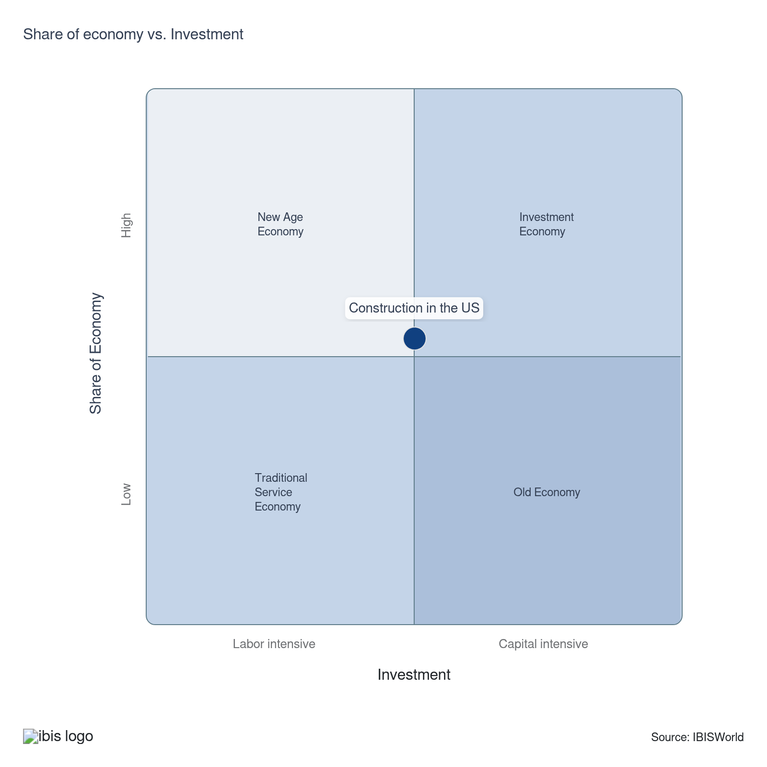

Key Ratios
Year | Revenue per Employee  ($) | Revenue per Enterprise  ($ Million) | Employees per Estab.  (Units) | Employees per Enterprise  (Units) | Average Wage  ($) | Wages/ Revenue  (%) | Estab. per Enterprise  (Units) | IVA/ Revenue  (%)
2004 | 297,400 | 0.9 | 2.9 | 2.9 | 53,512 | 18.0 | 1.0 | 27.1
2005 | 309,394 | 0.9 | 2.8 | 2.8 | 54,875 | 17.7 | 1.0 | 26.6
2006 | 295,115 | 0.9 | 3.0 | 3.0 | 55,151 | 18.7 | 1.0 | 27.1
2007 | 287,523 | 0.8 | 2.9 | 2.9 | 55,805 | 19.4 | 1.0 | 26.6
2008 | 264,145 | 0.8 | 2.9 | 2.9 | 56,267 | 21.3 | 1.0 | 27.0
2009 | 250,843 | 0.7 | 2.7 | 2.7 | 53,619 | 21.4 | 1.0 | 27.0
2010 | 264,007 | 0.7 | 2.5 | 2.5 | 53,051 | 20.1 | 1.0 | 26.0
2011 | 271,567 | 0.7 | 2.5 | 2.5 | 54,472 | 20.1 | 1.0 | 26.2
2012 | 274,560 | 0.7 | 2.5 | 2.5 | 55,297 | 20.1 | 1.0 | 26.9
2013 | 280,398 | 0.7 | 2.6 | 2.6 | 56,230 | 20.1 | 1.0 | 27.1
2014 | 292,150 | 0.8 | 2.6 | 2.6 | 57,629 | 19.7 | 1.0 | 27.1
2015 | 296,551 | 0.8 | 2.7 | 2.7 | 60,027 | 20.2 | 1.0 | 28.3
2016 | 299,069 | 0.8 | 2.8 | 2.8 | 60,705 | 20.3 | 1.0 | 23.8
2017 | 310,941 | 0.9 | 2.8 | 2.8 | 62,247 | 20.0 | 1.0 | 23.8
2018 | 307,785 | 0.9 | 2.8 | 2.8 | 62,443 | 20.3 | 1.0 | 29.0
2019 | 307,171 | 0.9 | 2.8 | 2.8 | 63,208 | 20.6 | 1.0 | 29.8
2020 | 307,342 | 0.9 | 2.8 | 2.8 | 60,983 | 19.8 | 1.0 | 29.5
2021 | 316,111 | 0.9 | 2.8 | 2.8 | 63,574 | 20.1 | 1.0 | 29.7
2022 | 340,719 | 1.0 | 2.8 | 2.8 | 62,339 | 18.3 | 1.0 | 27.9
2023 | 327,540 | 0.9 | 2.8 | 2.8 | 63,882 | 19.5 | 1.0 | 28.4
2024 | 330,389 | 1.0 | 2.9 | 2.9 | 67,099 | 20.3 | 1.0 | 29.0
2025 | 325,860 | 0.9 | 2.8 | 2.8 | 66,915 | 20.5 | 1.0 | 29.2
2026 | 323,382 | 0.9 | 2.8 | 2.8 | 66,811 | 20.7 | 1.0 | 29.3
2027 | 324,568 | 0.9 | 2.8 | 2.8 | 66,860 | 20.6 | 1.0 | 29.2
2028 | 325,706 | 0.9 | 2.8 | 2.8 | 66,907 | 20.5 | 1.0 | 29.2
2029 | 325,638 | 0.9 | 2.8 | 2.9 | 66,904 | 20.5 | 1.0 | 29.2
2030 | 325,707 | 0.9 | 2.8 | 2.9 | 66,907 | 20.5 | 1.0 | 29.2
2031 | 325,876 | 0.9 | 2.8 | 2.9 | 66,914 | 20.5 | 1.0 | 29.2
2032 | 326,112 | 0.9 | 2.9 | 2.9 | 66,924 | 20.5 | 1.0 | 29.2
*Figures are inflation adjusted to 2026
*Figures are inflation adjusted to 2026

10. Key Statistics
https://my.ibisworld.com/us/en/industry/23/key-statistics

Industry Data

Values
Year | Revenue  ($ Million) | IVA  ($ Million) | Estab.  (Units) | Enterprises  (Units) | Employment  (Units) | Wages  ($ Million)
2004 | 2,688,282.2 | 727,528.4 | 3,152,004 | 3,142,730 | 9,039,273 | 483,712.2
2005 | 2,881,144.9 | 765,702.8 | 3,318,562 | 3,308,554 | 9,312,217 | 511,011.3
2006 | 2,918,112.7 | 789,832.1 | 3,351,588 | 3,340,797 | 9,888,038 | 545,340.1
2007 | 2,853,733.2 | 760,167.8 | 3,468,812 | 3,457,171 | 9,925,243 | 553,877.6
2008 | 2,528,304.1 | 682,926.9 | 3,301,628 | 3,289,488 | 9,571,645 | 538,564.4
2009 | 2,112,747.6 | 569,708.5 | 3,168,430 | 3,156,284 | 8,422,581 | 451,613.8
2010 | 2,062,821.6 | 535,647.1 | 3,106,915 | 3,094,461 | 7,813,502 | 414,514.7
2011 | 2,058,177.9 | 539,337.2 | 3,045,707 | 3,033,209 | 7,578,890 | 412,835.6
2012 | 2,088,777.9 | 560,899.4 | 2,999,700 | 2,987,749 | 7,607,740 | 420,685.0
2013 | 2,197,935.2 | 595,232.0 | 3,026,925 | 3,014,875 | 7,838,623 | 440,768.8
2014 | 2,380,342.5 | 644,603.1 | 3,109,618 | 3,097,096 | 8,147,665 | 469,541.4
2015 | 2,502,389.0 | 709,365.9 | 3,112,404 | 3,099,241 | 8,438,300 | 506,523.0
2016 | 2,626,511.5 | 625,854.7 | 3,167,759 | 3,154,378 | 8,782,290 | 533,126.0
2017 | 2,806,915.0 | 668,526.8 | 3,209,730 | 3,195,566 | 9,027,150 | 561,911.4
2018 | 2,908,694.2 | 844,898.2 | 3,369,121 | 3,354,873 | 9,450,411 | 590,112.0
2019 | 3,009,543.2 | 895,808.9 | 3,498,927 | 3,484,309 | 9,797,621 | 619,286.1
2020 | 3,092,234.5 | 912,892.8 | 3,632,497 | 3,617,437 | 10,061,227 | 613,560.5
2021 | 3,113,317.8 | 924,617.9 | 3,567,047 | 3,551,336 | 9,848,812 | 626,125.9
2022 | 3,488,086.1 | 972,888.1 | 3,676,241 | 3,658,077 | 10,237,437 | 638,187.5
2023 | 3,464,422.6 | 984,152.5 | 3,732,188 | 3,713,298 | 10,577,090 | 675,687.9
2024 | 3,575,952.5 | 1,036,595.8 | 3,776,318 | 3,761,650 | 10,823,458 | 726,238.8
2025 | 3,514,255.5 | 1,025,791.2 | 3,803,977 | 3,795,397 | 10,784,545 | 721,647.8
2026 | 3,496,356.7 | 1,023,581.0 | 3,836,600 | 3,831,505 | 10,811,862 | 722,355.3
2027 | 3,586,303.2 | 1,048,415.7 | 3,906,897 | 3,899,975 | 11,049,464 | 738,771.5
2028 | 3,671,243.1 | 1,071,903.9 | 3,968,645 | 3,959,698 | 11,271,633 | 754,154.5
2029 | 3,734,874.3 | 1,090,016.6 | 4,032,789 | 4,023,511 | 11,469,392 | 767,353.9
2030 | 3,794,374.9 | 1,106,796.9 | 4,090,716 | 4,081,037 | 11,649,669 | 779,448.0
2031 | 3,852,478.2 | 1,124,053.9 | 4,148,163 | 4,138,162 | 11,821,903 | 791,054.1
2032 | 3,911,471.3 | 1,141,159.8 | 4,207,207 | 4,196,853 | 11,994,258 | 802,703.2

*Figures are inflation adjusted to 2026

Annual Change
Year | Revenue  % | IVA  % | Estab.  % | Enterprises  % | Employment  % | Wages  %
2004 | N/A | N/A | N/A | N/A | N/A | N/A
2005 | 7.2 | 5.2 | 5.3 | 5.3 | 3.0 | 5.6
2006 | 1.3 | 3.2 | 1.0 | 1.0 | 6.2 | 6.7
2007 | -2.2 | -3.8 | 3.5 | 3.5 | 0.4 | 1.6
2008 | -11.4 | -10.2 | -4.8 | -4.9 | -3.6 | -2.8
2009 | -16.4 | -16.6 | -4.0 | -4.0 | -12.0 | -16.1
2010 | -2.4 | -6.0 | -1.9 | -2.0 | -7.2 | -8.2
2011 | -0.2 | 0.7 | -2.0 | -2.0 | -3.0 | -0.4
2012 | 1.5 | 4.0 | -1.5 | -1.5 | 0.4 | 1.9
2013 | 5.2 | 6.1 | 0.9 | 0.9 | 3.0 | 4.8
2014 | 8.3 | 8.3 | 2.7 | 2.7 | 3.9 | 6.5
2015 | 5.1 | 10.0 | 0.1 | 0.1 | 3.6 | 7.9
2016 | 5.0 | -11.8 | 1.8 | 1.8 | 4.1 | 5.3
2017 | 6.9 | 6.8 | 1.3 | 1.3 | 2.8 | 5.4
2018 | 3.6 | 26.4 | 5.0 | 5.0 | 4.7 | 5.0
2019 | 3.5 | 6.0 | 3.9 | 3.9 | 3.7 | 4.9
2020 | 2.7 | 1.9 | 3.8 | 3.8 | 2.7 | -0.9
2021 | 0.7 | 1.3 | -1.8 | -1.8 | -2.1 | 2.0
2022 | 12.0 | 5.2 | 3.1 | 3.0 | 3.9 | 1.9
2023 | -0.7 | 1.2 | 1.5 | 1.5 | 3.3 | 5.9
2024 | 3.2 | 5.3 | 1.2 | 1.3 | 2.3 | 7.5
2025 | -1.7 | -1.0 | 0.7 | 0.9 | -0.4 | -0.6
2026 | -0.5 | -0.2 | 0.9 | 1.0 | 0.3 | 0.1
2027 | 2.6 | 2.4 | 1.8 | 1.8 | 2.2 | 2.3
2028 | 2.4 | 2.2 | 1.6 | 1.5 | 2.0 | 2.1
2029 | 1.7 | 1.7 | 1.6 | 1.6 | 1.8 | 1.8
2030 | 1.6 | 1.5 | 1.4 | 1.4 | 1.6 | 1.6
2031 | 1.5 | 1.6 | 1.4 | 1.4 | 1.5 | 1.5
2032 | 1.5 | 1.5 | 1.4 | 1.4 | 1.5 | 1.5

*Figures are inflation adjusted to 2026

DISCLAIMER
This product has been supplied by IBISWorld Inc. (‘IBISWorld’) solely for use by its authorized licenses strictly in accordance with their license agreements with IBISWorld. IBISWorld makes no representation to any other person with regard to the completeness or accuracy of the data or information contained herein, and it accepts no responsibility and disclaims all liability (save for liability which cannot be lawfully disclaimed) for loss or damage whatsoever suffered or incurred by any other person resulting from the use of, or reliance upon, the data or information contained herein. Copyright in this publication is owned by IBISWorld Inc. The publication is sold on the basis that the purchaser agrees not to copy the material contained within it for other than the purchasers own purposes. In the event that the purchaser uses or quotes from the material in this publication – in papers, reports, or opinions prepared for any other person – it is agreed that it will be sourced to: IBISWorld Inc.

